Router configuration for port forwarding with putty tunneling
Before you start this exercise make sure your laptop WiFi interface is not set to share the connection !!!!!!
In this exercise when we're done the pi will be behind the router, the router will be connected to the laptop, sharing the laptop's wireless access to the outside internet. Our desire is use port forwarding to provide outside access to the pi's ssh service.
- Our first step is to reset the wireless router to factory defaults. With router powered on, find the reset button on the bottom side and hold it in for 15 seconds. Once you release it the power LED on the router should start flashing. The reset button is resessed so you need a pen or something to push it in.
- The router has 5 ethernet ports, 4 have blue lables 1-4 (LAN side) and the fifth has a yellow internet lable (WAN side). Connect your laptop to one of the LAN ports via a cat 5 cable.
- By default the router will have dhcp running on the LAN side, so it should assign your laptop an IP address. Bring up a command prompt and use ipconfig to find the IP address assigned to your laptop’s Network Adaptor. When you do this note the Default gateway IP address, as this is the IP address of your router.
- Use your web browser to surf to the IP address of the wireless router. You should get something like this if you can successfully access the router:
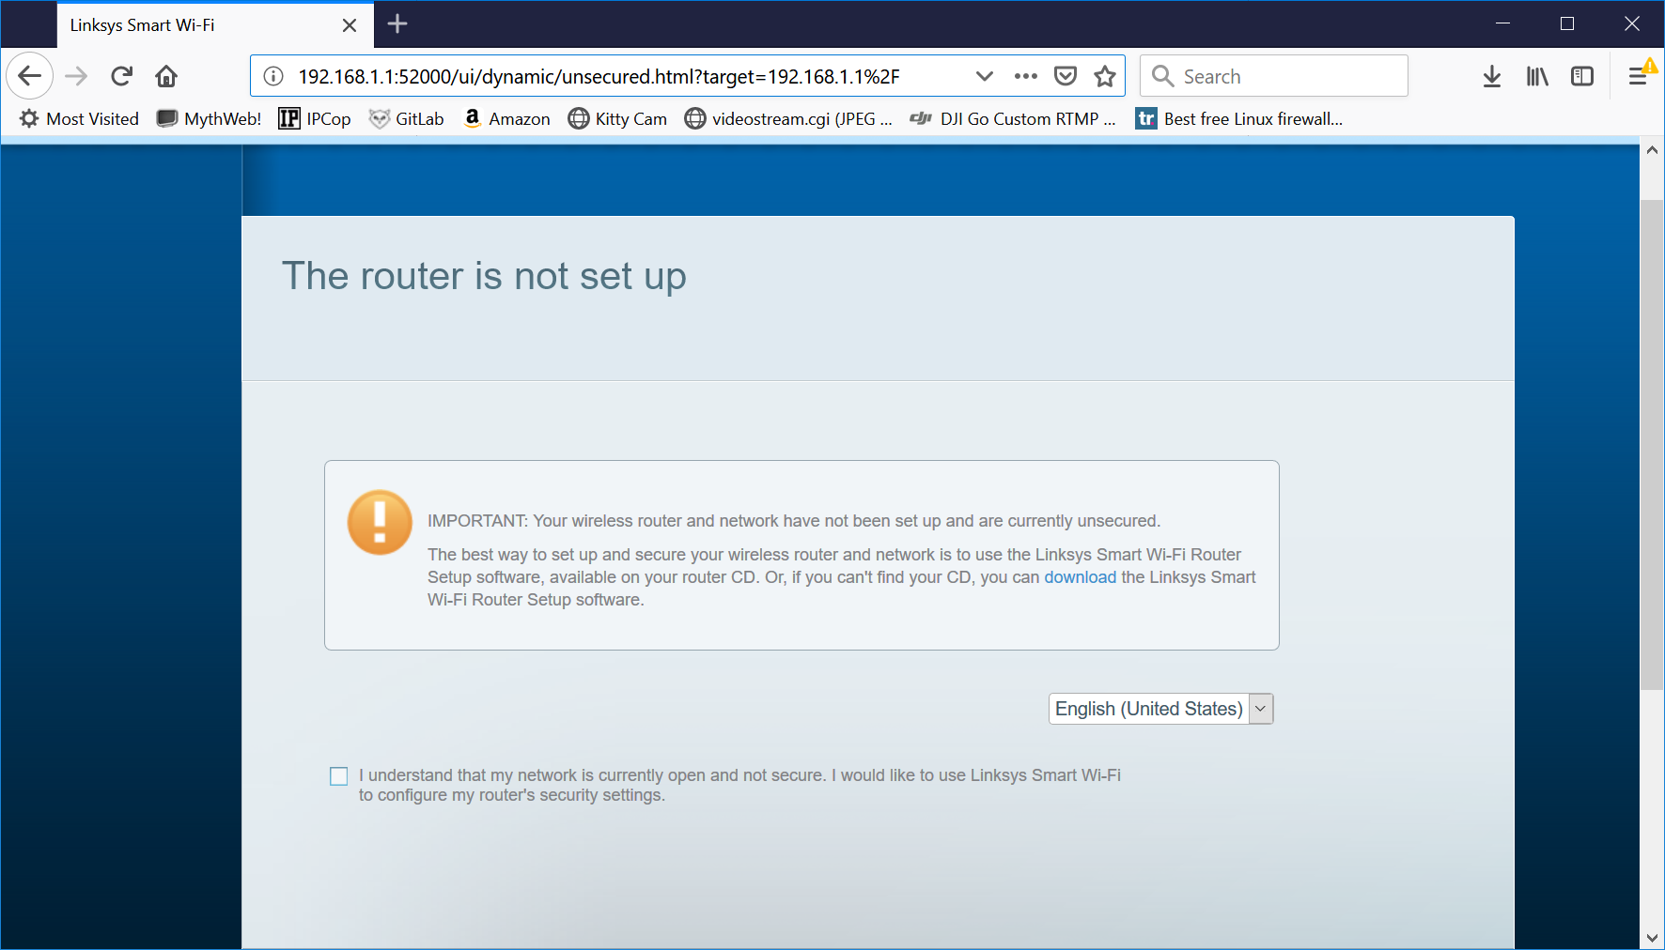

- Check the “I understand” check box and click the “Continue” button. You should get something like this:
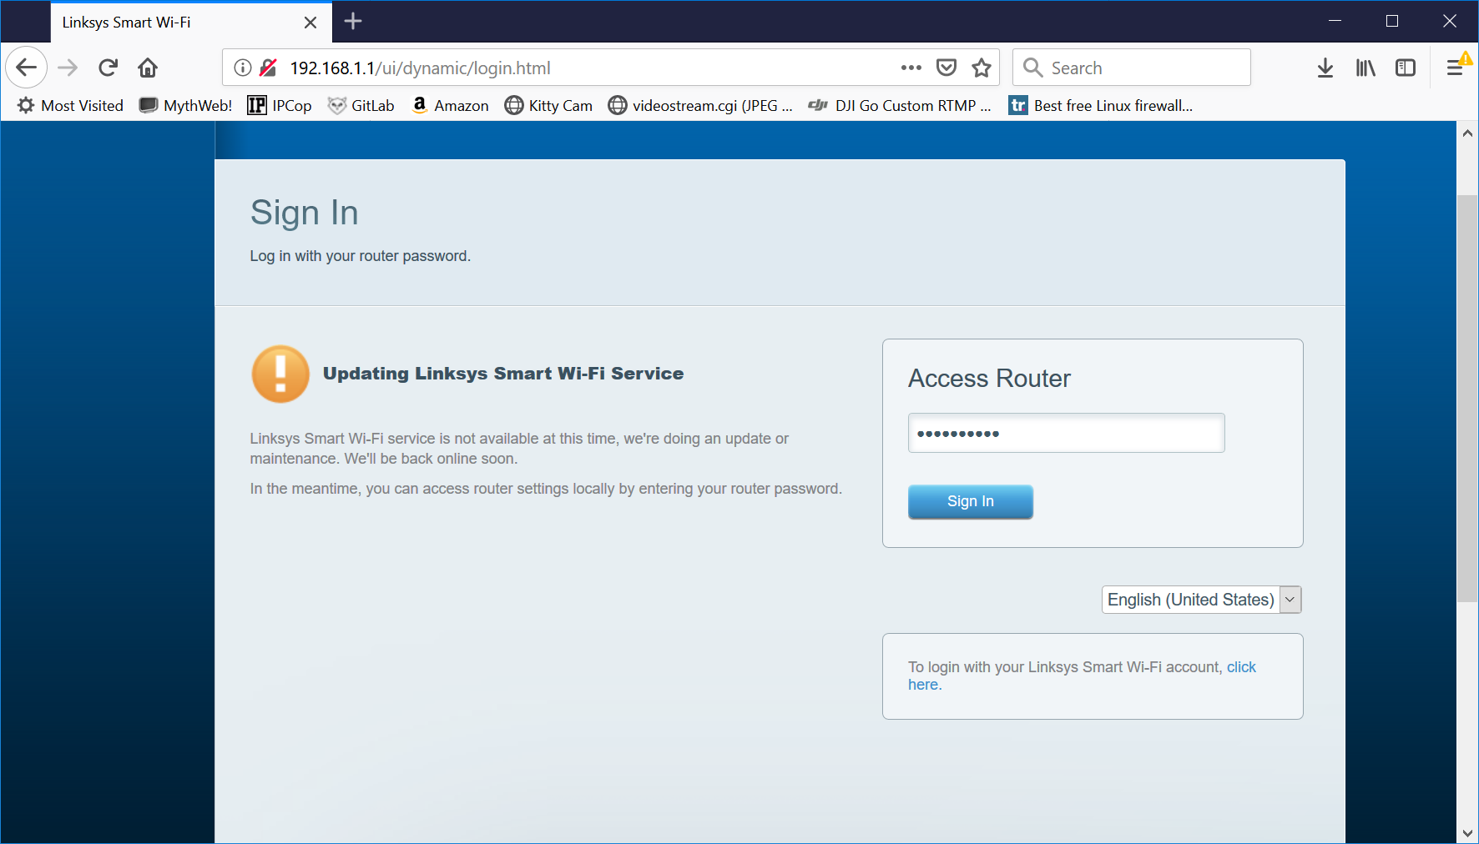
- The default password is admin, enter this in the text box and click the “Sign In” button
- First thing want to do is change the device password, On the left hand side click on “Connectivity”
- On the bottome left hand side you should see “Router Password” , click on “edit”
- The screen will look like the following, where you will enter the current password of admin and then the updated password of cyberpatriot
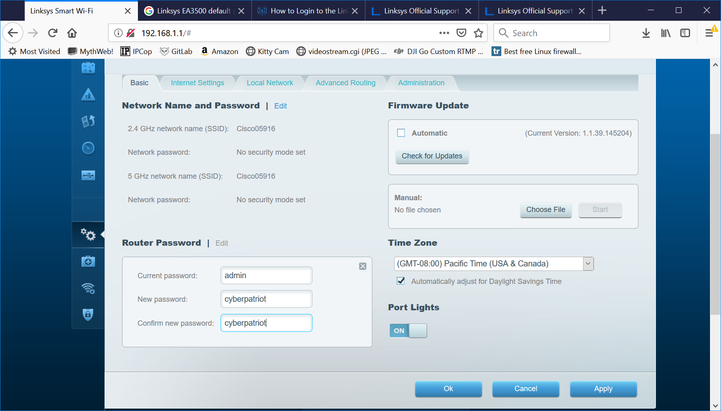
- Click the “OK” to have the password update apply and click “Yes” in response to the popup menu.
- Back under “Connectivity the time zone will have defaulted to “Pacific”, set it to the correct time zone for our location and the click the “OK” button.
- As we’re not using the wireless network on the router we want to disable it. Select “Wireless” from the left hand menu then next to the 2.4 Ghz network select “edit”, uncheck “Enabled”. Next select “Edit” next to the 5 Ghz network and uncheck “Enabled”. Finally hit the “Ok” button to apply the change. You’ll get a popup to which you want to select “Yes”, which is followed by second popup to which you click “Ok”.
- Once the router returns from appling the previous step we want to enable ping request on the external WAN interface. Select “Security” from the left hand menu, uncheck “Filter anonymous Internet request” and click the “Ok” button.
Now we need to set up the PI. You PI SSD card has already been initiallized.
- Connect the USB to TTL adapter to the ARM board console port
Pull out your USB to TTL adapter. This adapter allows you to connect from a PC USB port to the Pi console port.

For the Orange Pi one the three pens for the console port are next to the Network slot. From the edge of the board they are Transmit Data (TXD) , Receive Data (RXD) and Ground (G) .

For the Orange Pi PC the three pens for the console port are between the power connector and the HDMI connector on one of the long edges of the board. Starting with the pin closes to the power connector they go Ground (G) , Receive Data (RXD) and Transmit Data (TXD).

You connect the USB RXD line to he Pi TXD line, the USB TXT to the Pi RXD line and the USB G to the pi G.
We will not be using the 5V pin to power the pi this time

- Next set up the USB to TTL device between the pi and the laptop
You plug the USB to TTL adapter into you laptop. If the drivers have not been installed for this device you should get an error message indicating the drivers need to be installed.

If you need to install the driver you can grab it from http://connectionblocks.com/tools/ . The driver file is CP210x_Windows_Drivers.zip

If you need to install the driver, after downloading the file right mouse click on the file and select “Extract All”. It’ll pop up a window. Just click on the “Extract” button.

The laptops are 32 bit machines, you can verify this by clicking the Windows button on the task bar, right mouse click on “Computer” and select “Properties”. The “System type” will be either 32-bit or 64-bit Operating System. For a 32 bit machine you run CP210XVCPInstaller_x86 and for a 64 bit machine run CP210XVCPInstaller_x64. Select the “Run” button in the pop up. Respond to any queries as appropriate, finishing with the “Finish” button.

Inserting the USB to TTL device, with the drivers loaded should add a new “COM” device to your computer. To find the device, in the Windows button search field enter device and then select “Device Manager”. Click the triangle next to Ports to expand this. If all when well there should be a “Silicon Labs CP210x ...” device that identifies a COMx name, x is a number. We need this COM name to connect to the console port.
- Start putty. If it isn’t already in the laptop “Download” folder you can download it from: https://www.chiark.greenend.org.uk/~sgtatham/putty/latest.html. You want the 32 bit Alternative binary file for putty.exe on this page.
In putty select the Serial button. Change the Serial Line text box to match the COMx name you saw in the Device Manager above. Change the speed to 115200. In the Saved Session field enter pi and then click the “Save” button. Then click the open button.

- Next connect your pi to one of the router internet ports via the cat 5 cable and then power on your pi. Connect the power cable to your Pi and you should see messages in the putty windows as the pi boots. If all goes well, in the putty window, while the Orange Pi is booting, you will see the console messages streaming out and it will end with a login prompt. The user-name is root and the initial password is 1234.
After you enter this it will ask you for the current password, enter: 1234
It’ll ask you to enter a new password, enter: orangepi
It’ll ask you to verify this password, enter: orangepi

If this is successful it will ask you to provide a user-name enter: pi
It’ll ask you for a password for this user, enter: orangepi
It’ll ask you to verify this password, enter: orangepi
It’ll ask you for a Full Name, enter: orange pi
It’ll ask you for a Room Number, just hit the enter key
It’ll ask you for a Work Phone, just hit the enter key
It’ll ask you for a Home Phone, just hit the enter key
It'll ask you for an Other, just hit the enter key
It’ll ask you if this information is correct, assuming it is enter: Y
It’ll tell you something about your display setting and ask if you want to change them, enter: n

It’ll tell you a reboot, but wait

- Disable daily auto updates to keep them from getting in the way later:
Execute the following at the orangepi command prompt
sudo systemctl disable apt-daily.service
sudo systemctl disable unattended-upgrades.service
sudo systemctl disable apt-daily.timer

- Now reboot to finish re-sizing the file system, enter: shutdown -r now
- Go back to the web browser and access the router, select “Device List”.
- Your orange pi should be in the list. Click on it to get the IP and MAC address of your pi.
- Bring up another putty window and see if you can connect via ssh to your pi, go ahead and log in.
- Verify the IP and MAC address via: ifconfig eth0
- We want the router to always assign the same IP address to the PI. So via the router interface on the left hand menu, select “Connectivity”
- Select the “Local Network”, then at the bottom right of the page click the “DHCP reservations” link
- Click the check box associated with the pi and then click the add DHCP reservation button and then click the “OK” button.
- It’ll tell you the route is making changes, click “OK”, it’ll take a little while for the browser to return
- If you click the “DHCP reservation” link again you should see a line indicating your PI has a reservered IP address. Click “OK” to get out of the screen.
- Now we need to add a port forwarding entry to allow connections from outside the router to access your PI. From the left hand menu select “Security”.
- Select the “Apps and Gaming” tab and then click the “Single port forwarding” link.
- Click the “Add a new single port forwarding” button. Enter
Application: pi ssh
External Port: 22222
Internal Port: 22
Protocol: TCP
Device IP#: 192.168.X.X This is the IP address of your pi
- Click the “Save” link, then click the “OK” button.
- We now want to move the cat 5 cable connected to the laptop from the router “Ethernet” port over to the Yellow “Internet” port.
- Next on the laptop we want to enable internet sharing for your wireless interface. We want to share it with devices connected to the laptop Network Interface Card, which is currently connected to router via the cat 5 cable. In the windows search bar enter: Network Status
- Click on the “Network Status” application and then click the “change adaptor setting” link
- Right click on the Wi-Fi adaptor and select “Properties” from the menu
- Click the “Sharing tab”
- Click the “Allow other network users to connect through this ....” and then if there is pull down select the device the equates to you’re laptops Network Interface Card “NIC”. Finally click the “OK” button.
- In the windows command prompt execute: ipconfig
- You’re looking to verify the NIC interface was assigned the address 192.168.137.1
- To make sure we don’t have a lot of bad arp information, first start a command windows as administrator and then do the following
- Clear the arp table via: arp -d
- In the putty window connected to the pi console execute: ping 192.168.137.1
- Now back in the Windows command prompt window check for devices connected to this 192.168.137.1/24 network with: arp -a
- Hopfully you will see a 192.168.137.X address besides 192.168.137.255. This should be the IP address assigned to your router. You can try using the web browser to access the router at this address, however it shouldn’t work.
- If we have an address then you should be able to connect to the address on port 22222 using putty. If you login prompt port forwarding is working. Login. If everything is working correctly in this pi putty window you should be able to reach the internet. Try: ping www.google.com
- As we’re on the internet side of the firewall we can no longer directly access the web interface for the router. However now that we have a port forwarding to the PI we can access the router interface by tunneling through the pi. Bring up a putty to configure a new connection, fill in the IP of your PI and port 22222, then in the left hand menu expand ssh and select “Tunnels”:
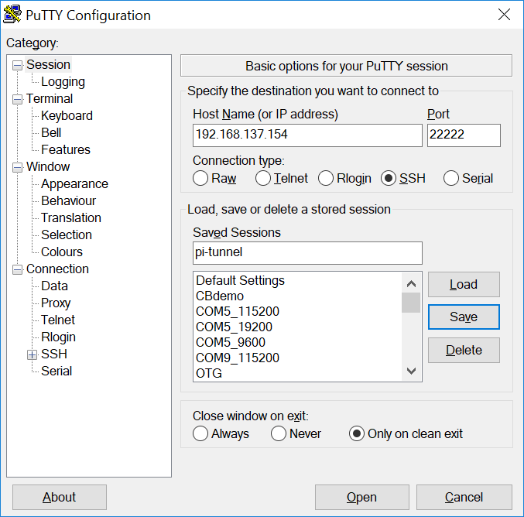

- Set things to create a tunnel by entering 1080 in the source port field and 192.168.1.1:80 in the Destination field, then select the “Add” button, which should give you something like this:
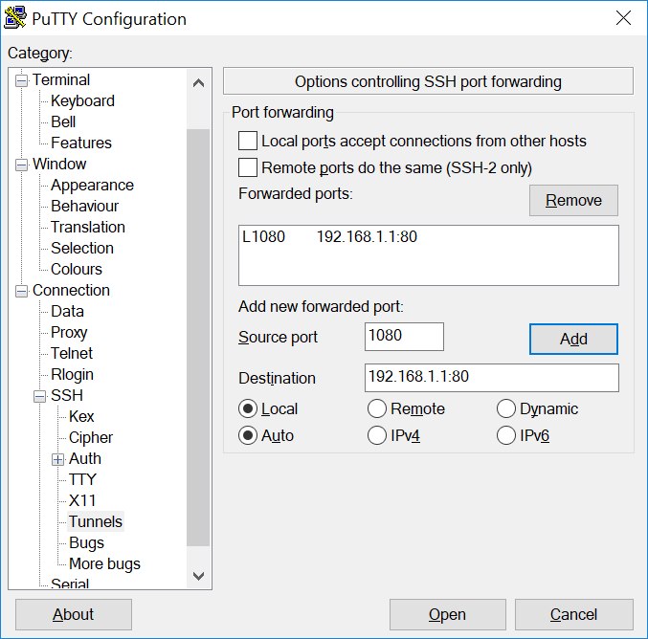
- You might want to select session in the left side menu so you can save this. Then select the “Open” button and assuming you get the login prompt login.
- Finally back on your laptop surf to http://localhost:1080/ and you should see


