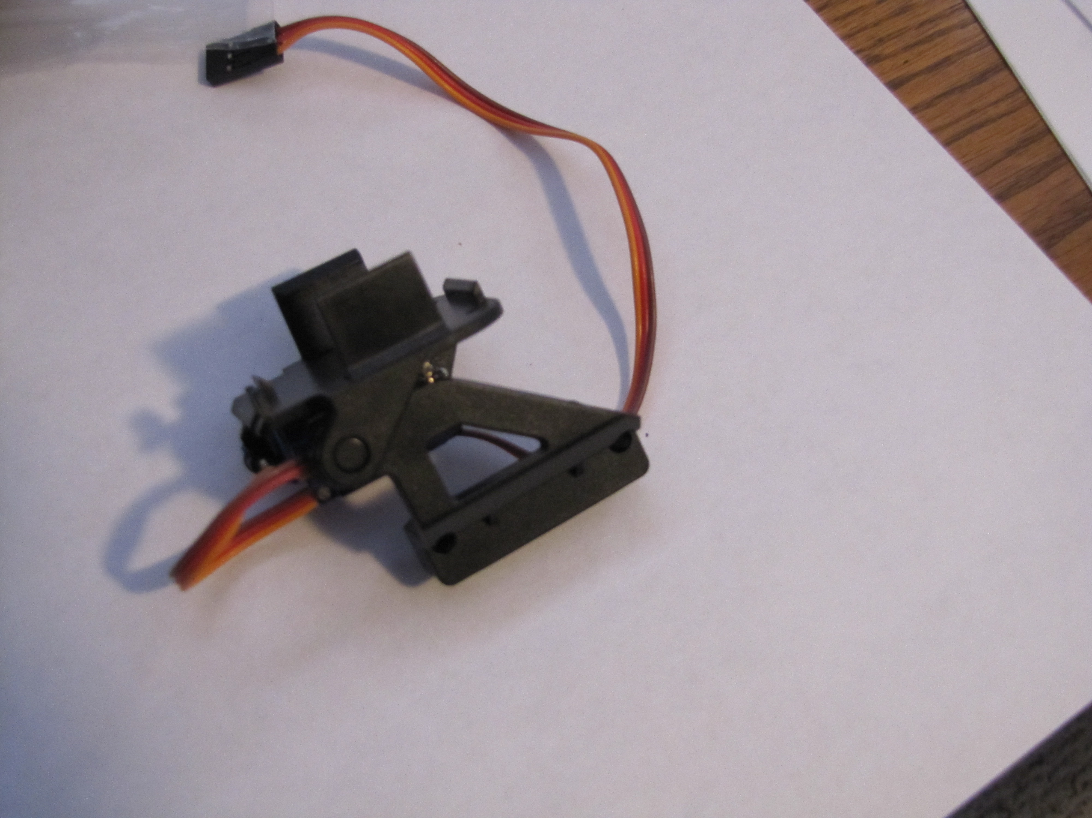
The first step is connect the top of the gimbal to the side. You have to slide the bump between the servo connected to the top piece and the side of the top piece.

Once you have this together flip it over. Temporary put the double arm on the servo gear and use it to rotate clockwise until it stops. Then remove the double arm.
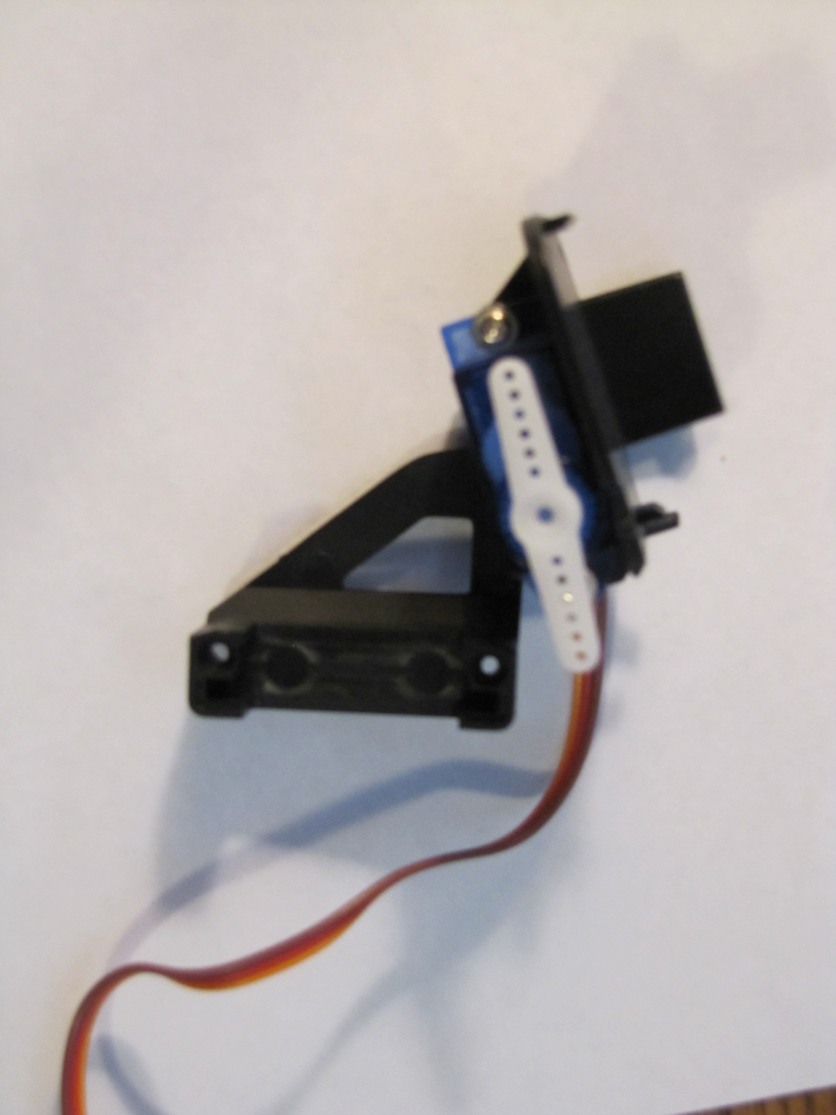

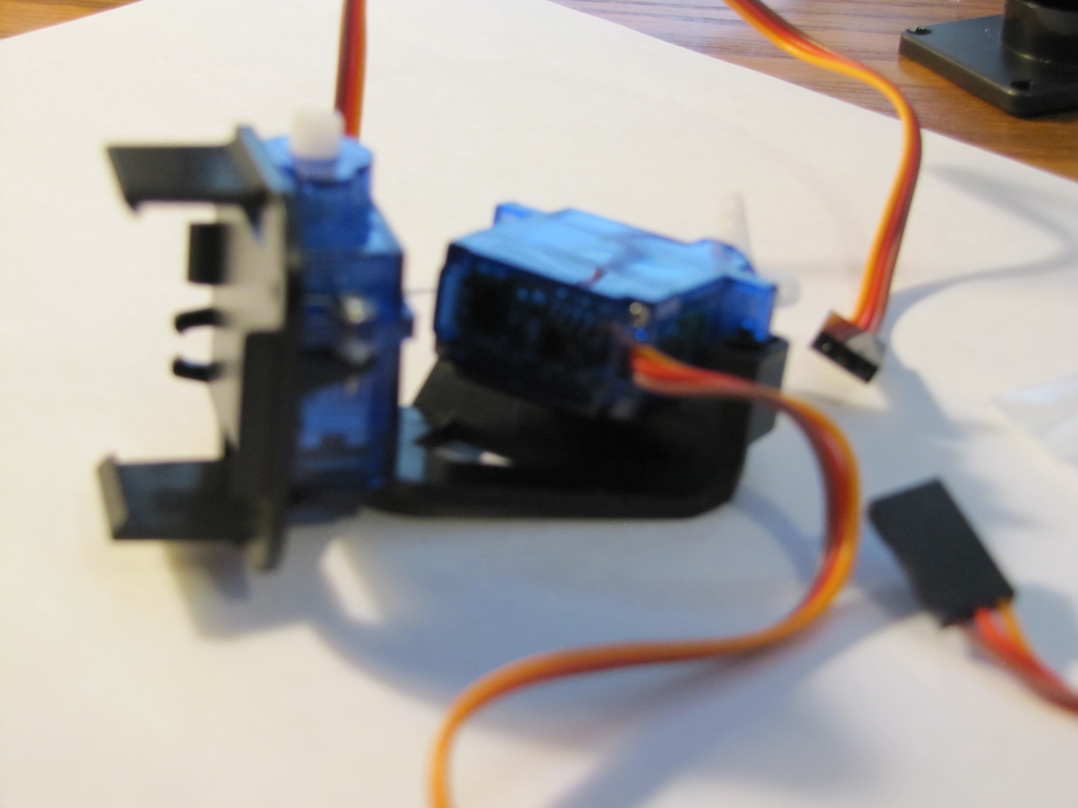
Now slide the second servo into place.

Place the four prong arm on the second servo and rotate it back and forth. You want to stop it in the middle, then pull the arm off and realign it so it looks like this. The rounded ends should be pointing to the front and back. Use one of the screws that was in with the servo arms to screw the arm into place.

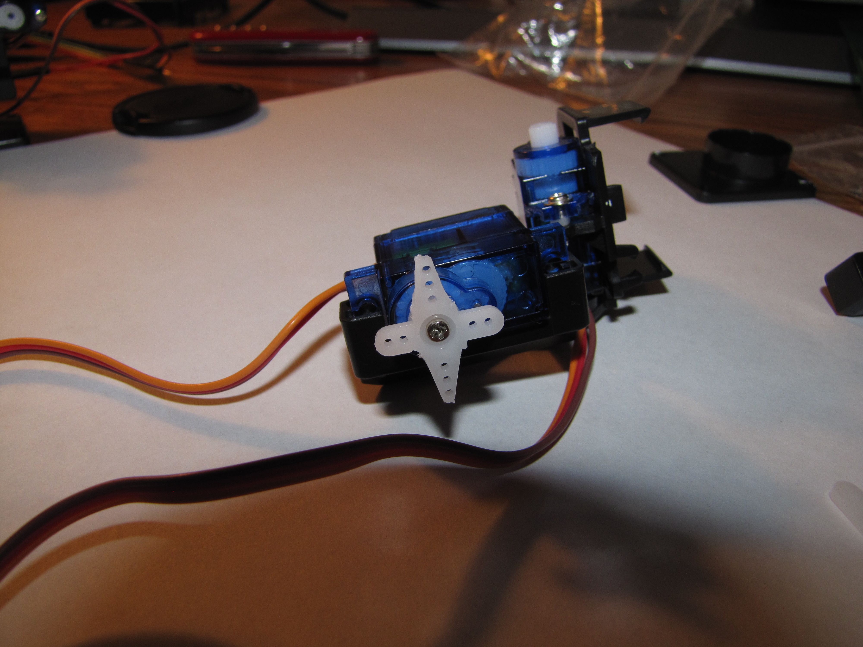

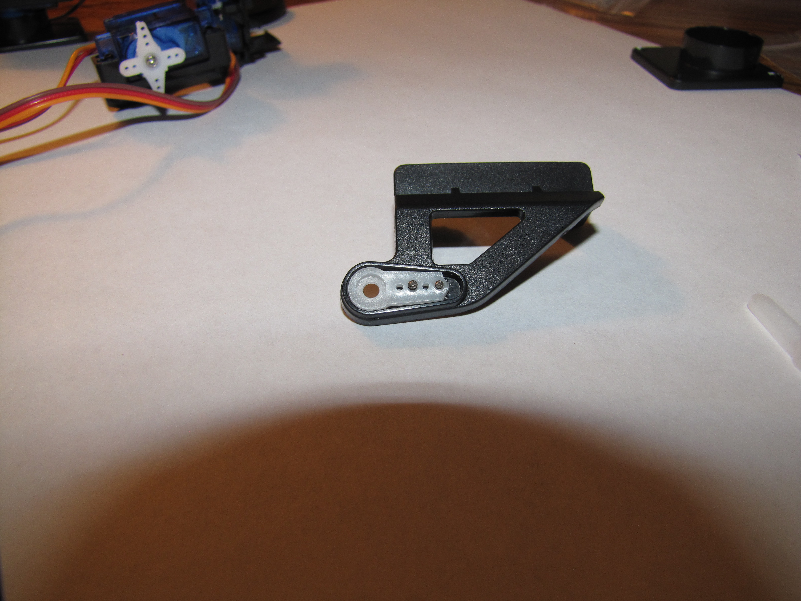
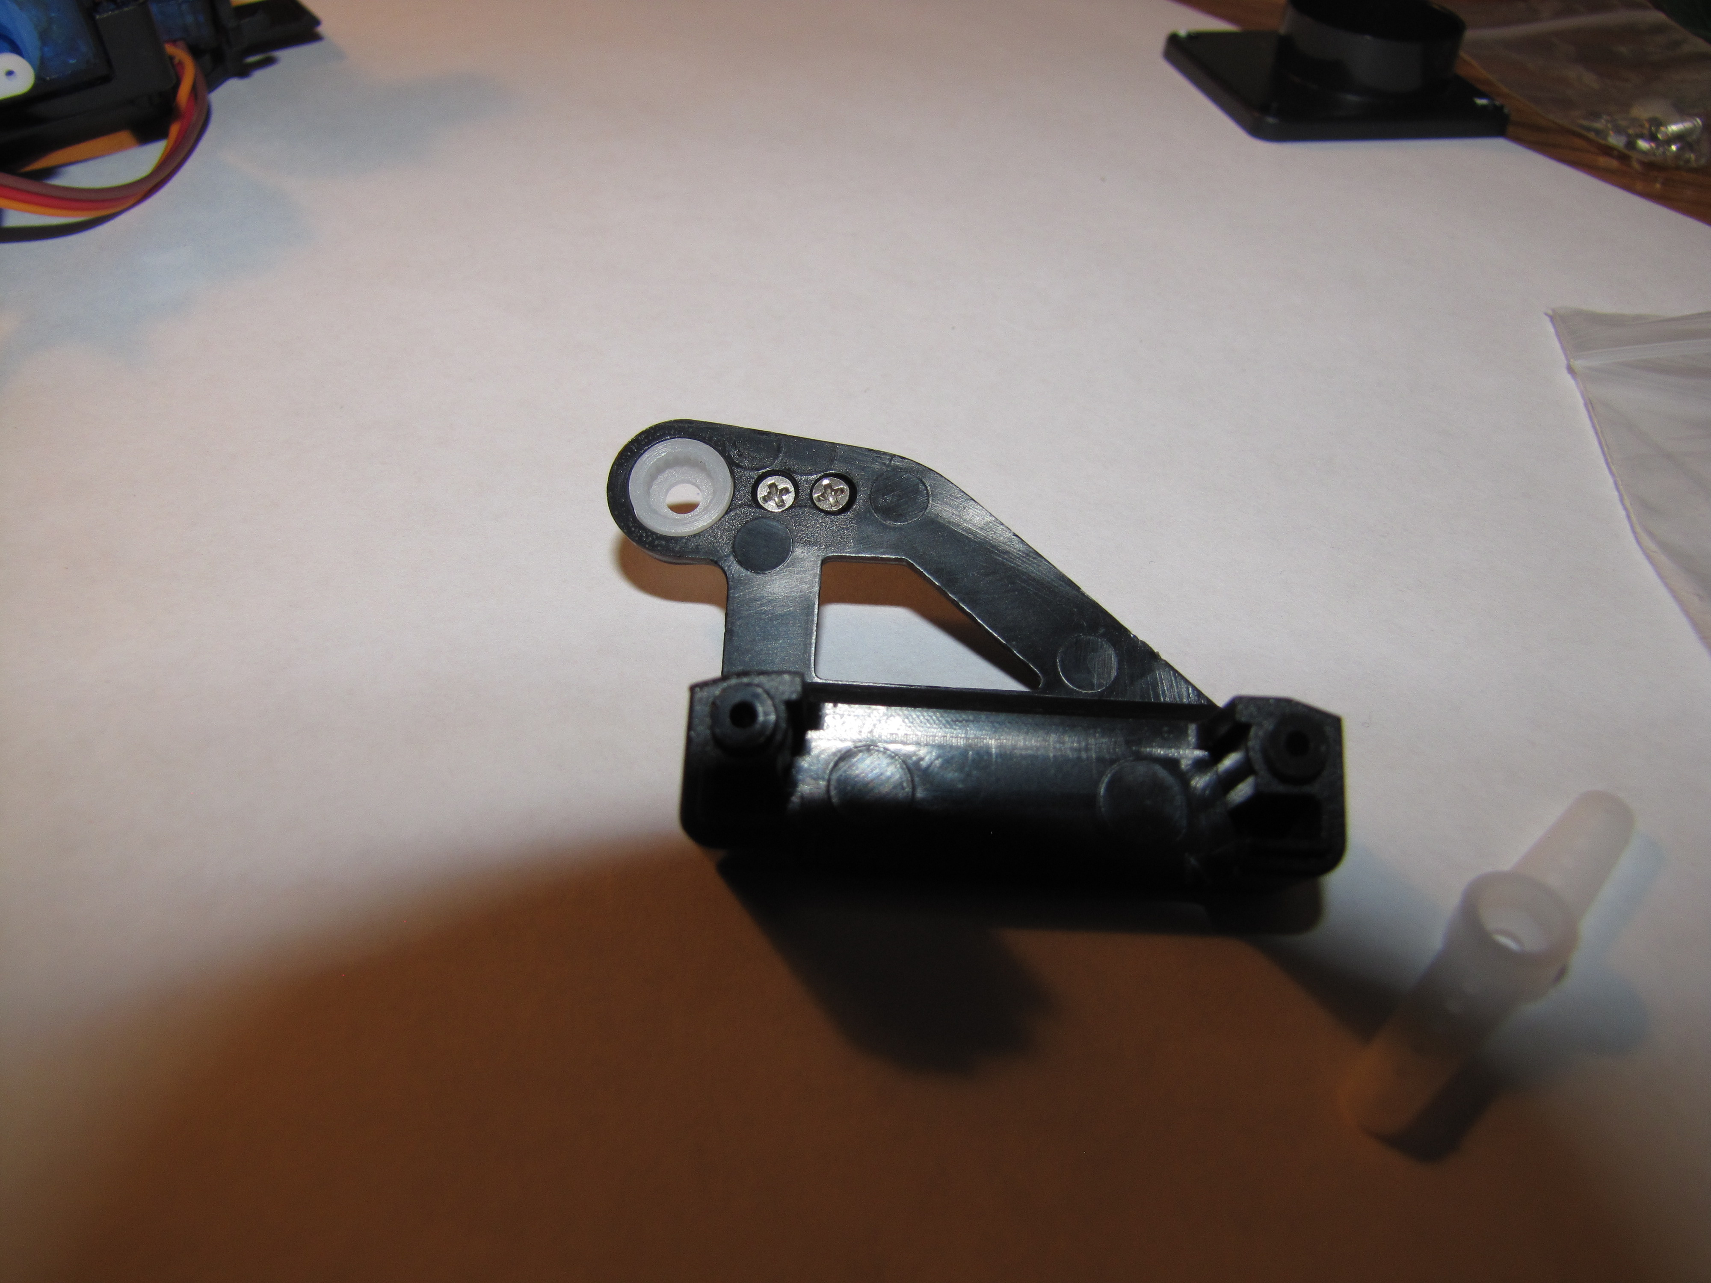
Now we want to screw the single arm servo into location. Where the servo gear plugs in in oriented to this side. Use two of the smallest screws to mount this is place.

Rotate the top so the top servo touches the bottom servo then slide the side into place.

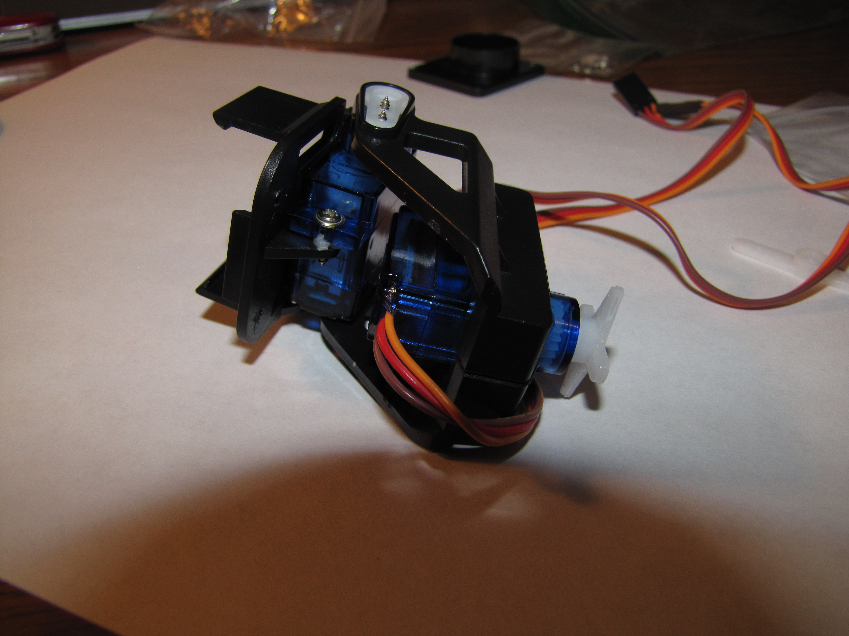
At this point you should you should very the top servo can move from this up to the down position and back.

Now put the bottom in place so it’s oriented like this and use the other two very small screws to screw it in place from the bottom.
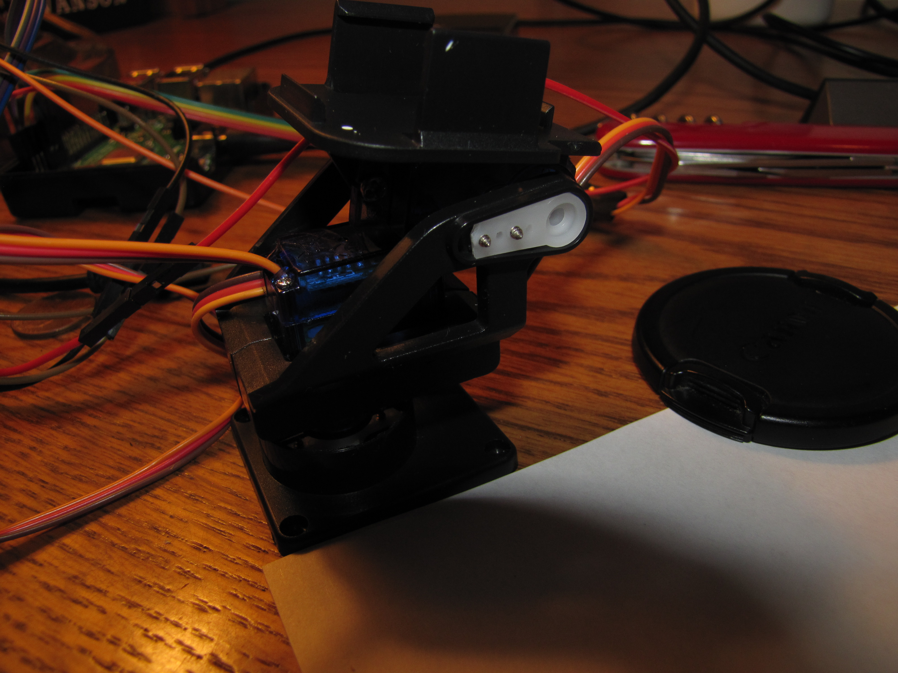
Use the second screw from the bag with the servo arm to connect the top servo arm to the servo.

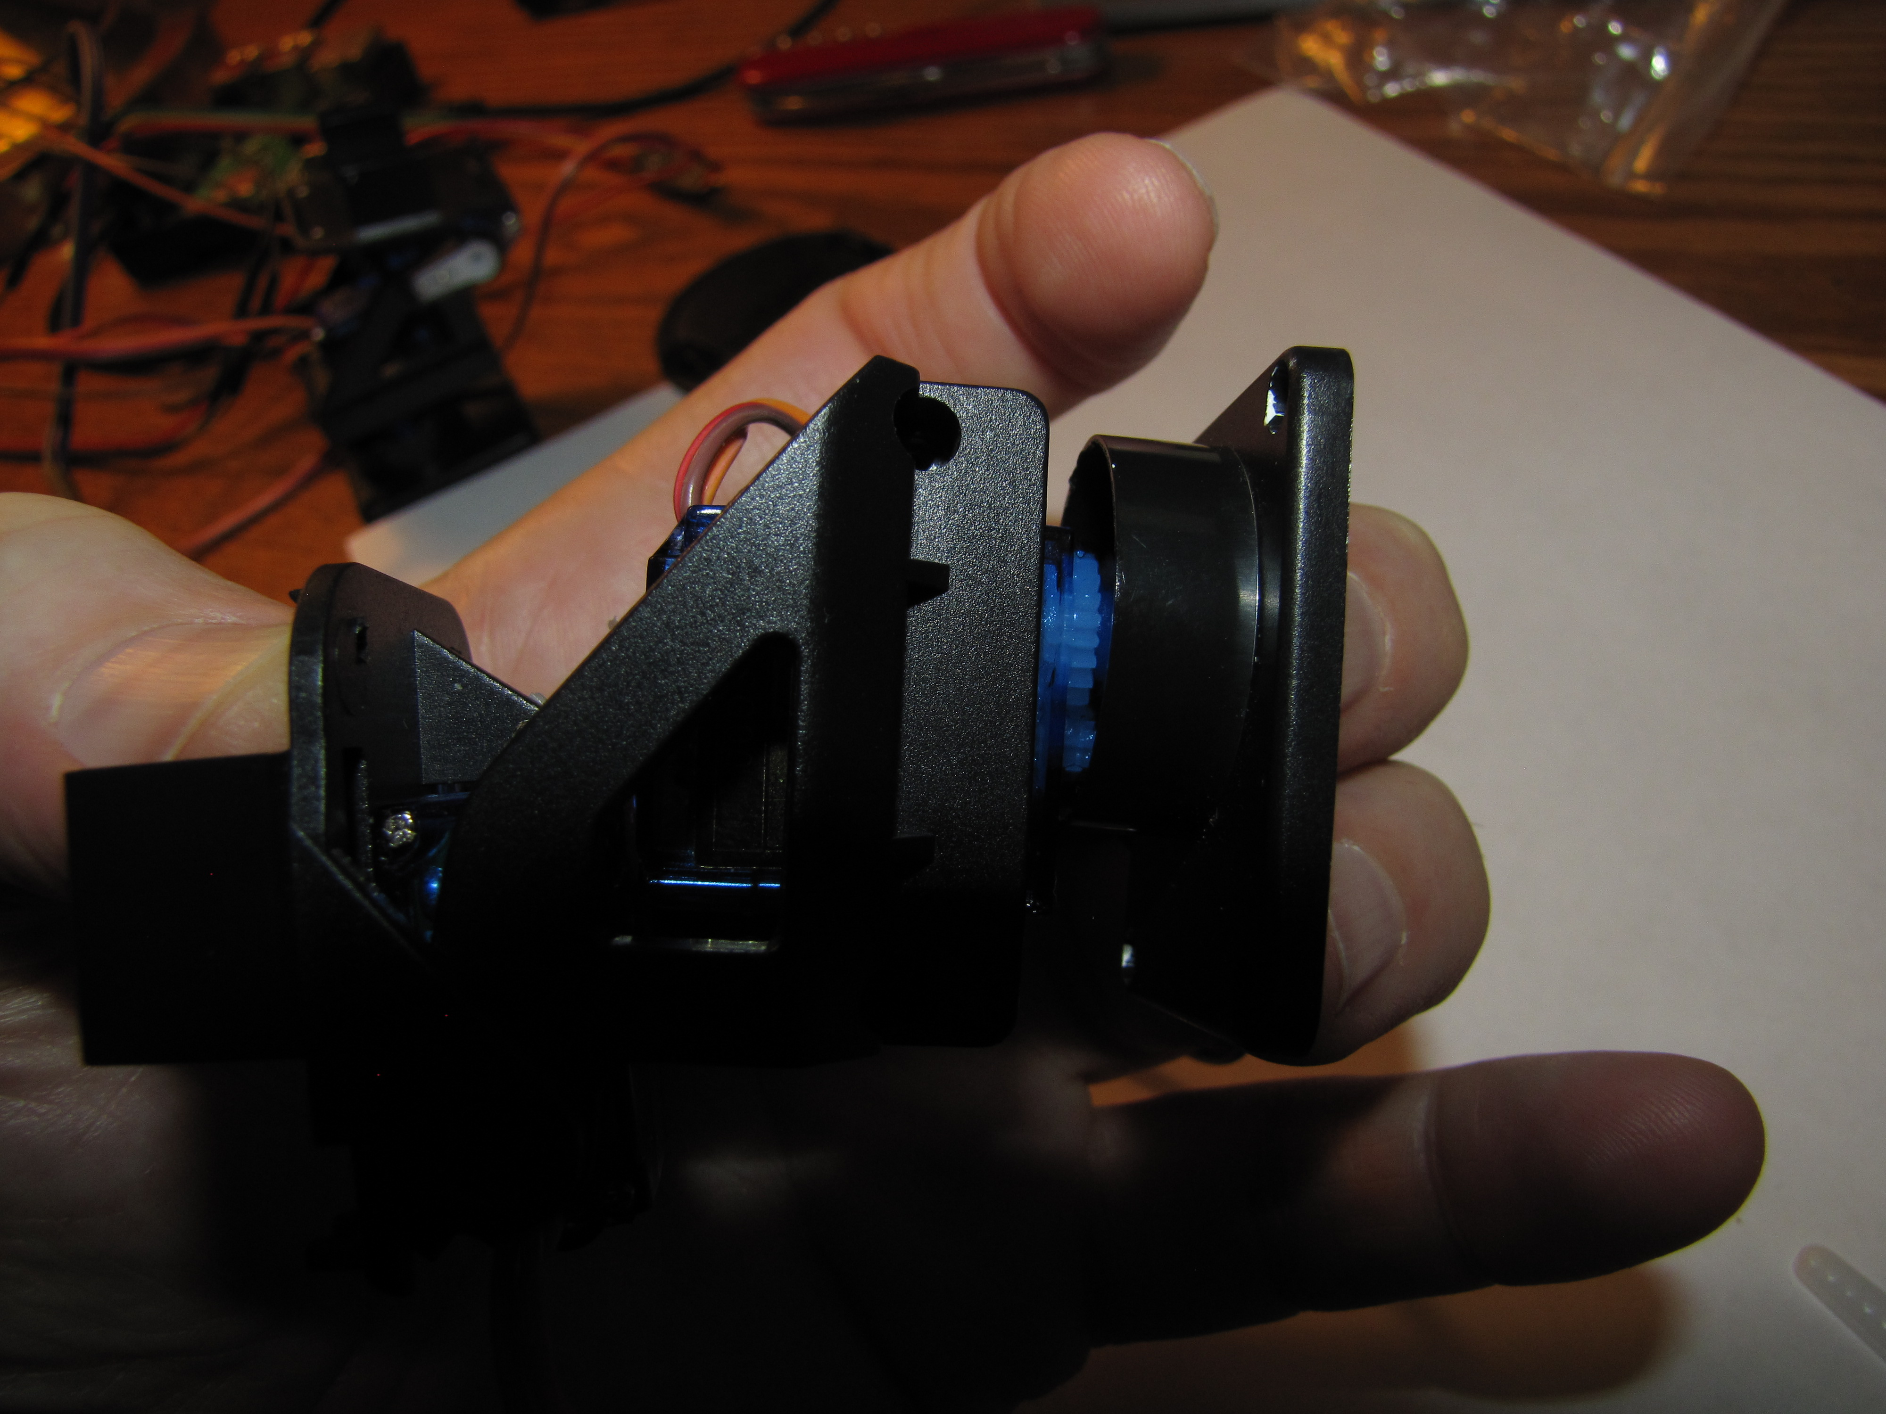
The primary screw bag has two pointy screws you use to hold the two side pieces of the servo together.

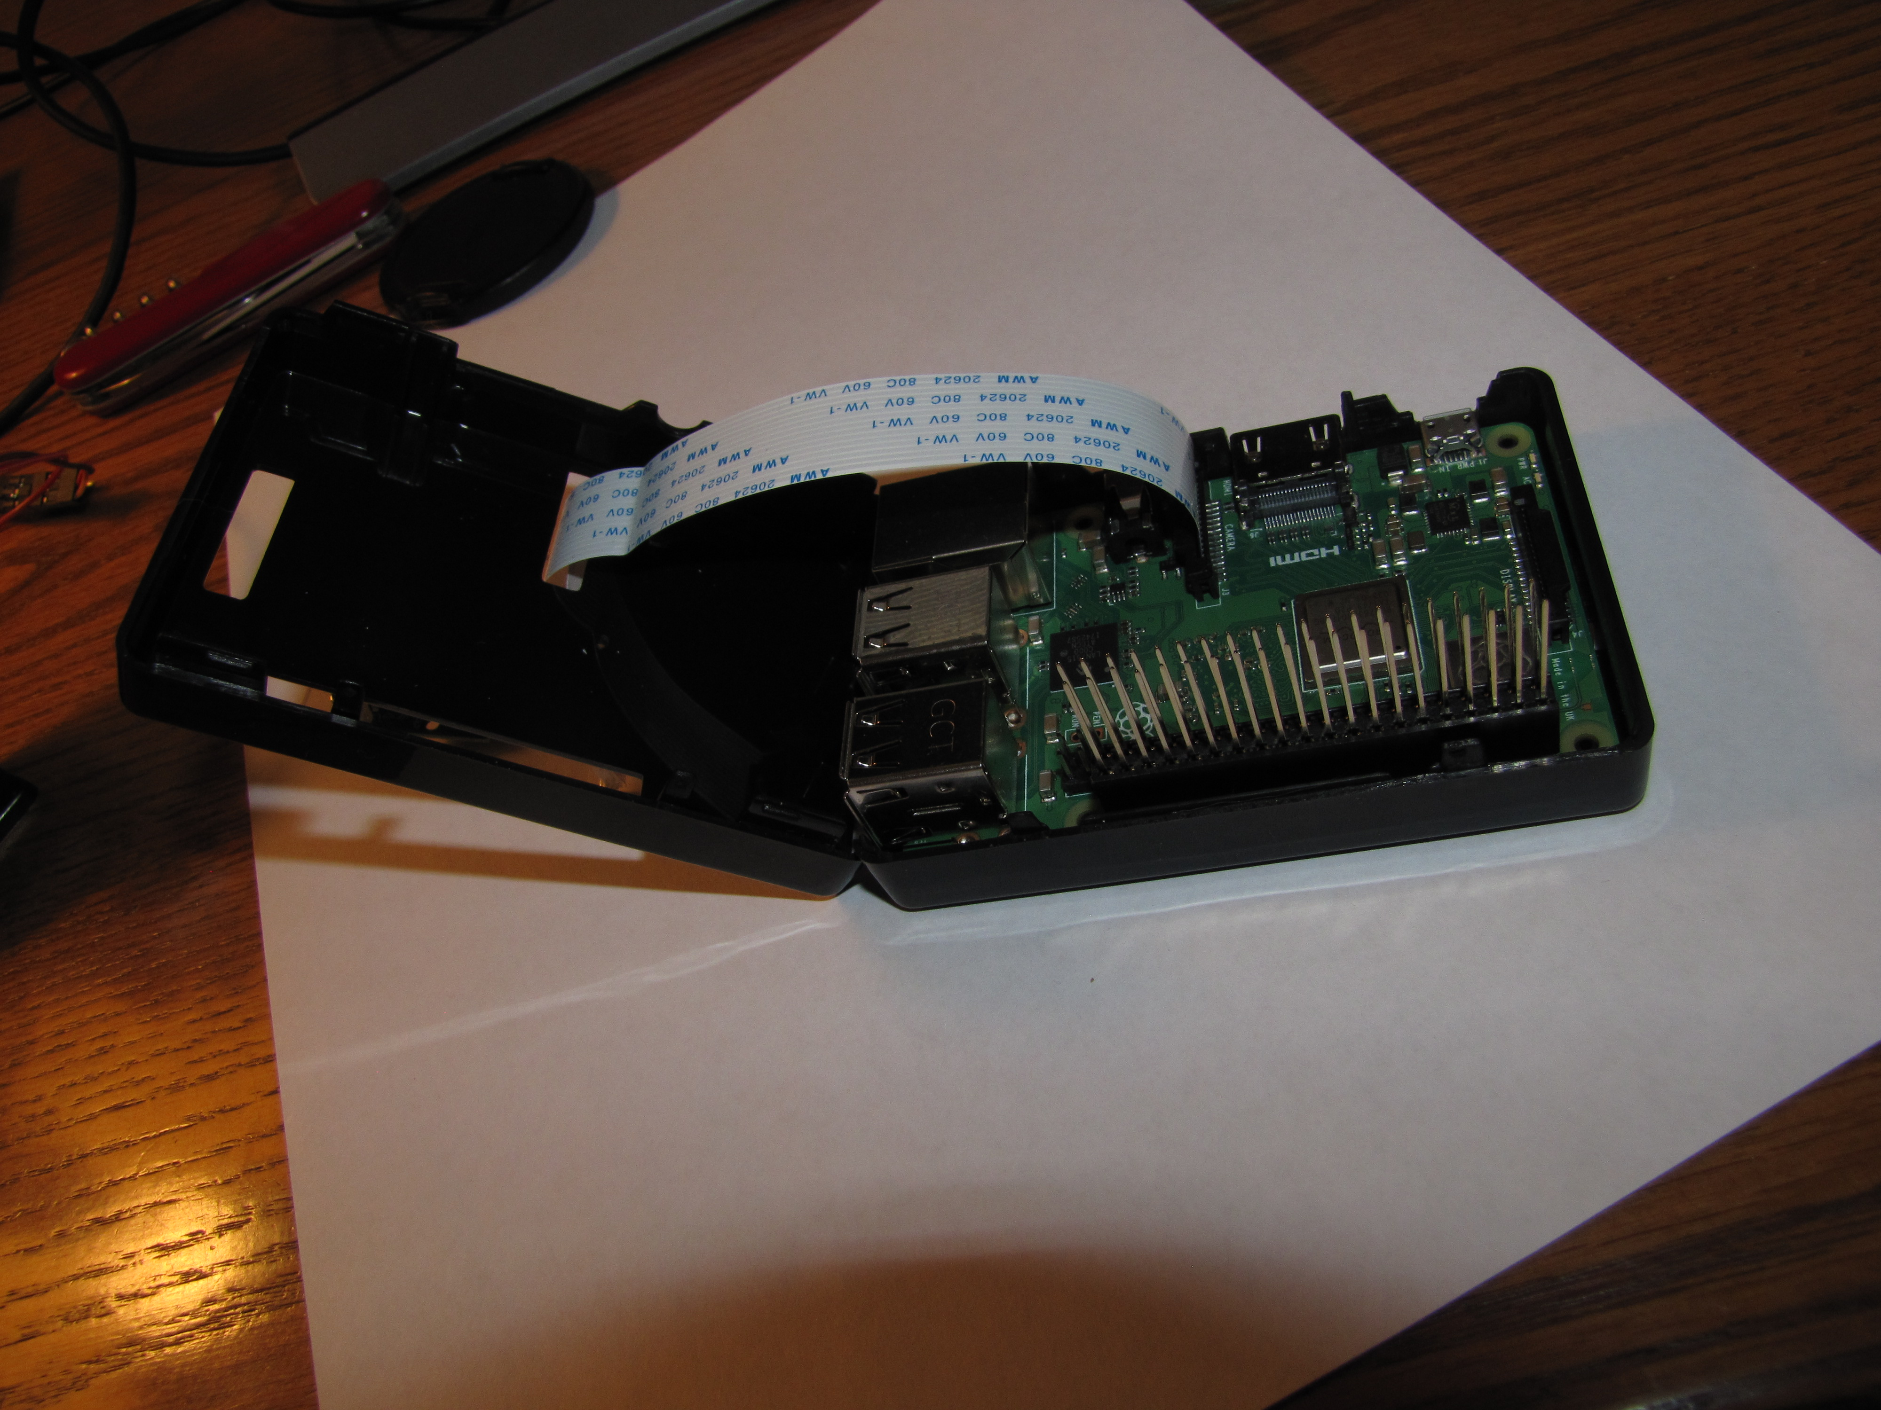
Now that the servo is together we want to connect the camera to the board and put the 40 pin header extender in place. You want to the camera cable through the pi case top. The blue at the end of the camera cable ends up on the side with the USB connectors. So silver end of the cable faces this side. To put the cable in place you gently lift up on the socket latch ends. It just lifts up, it does not come off the board. Slide the cable into the slot and push the socket latch back down. Finally slide the 40 pin header extender in place. Then flip the case top back into place.

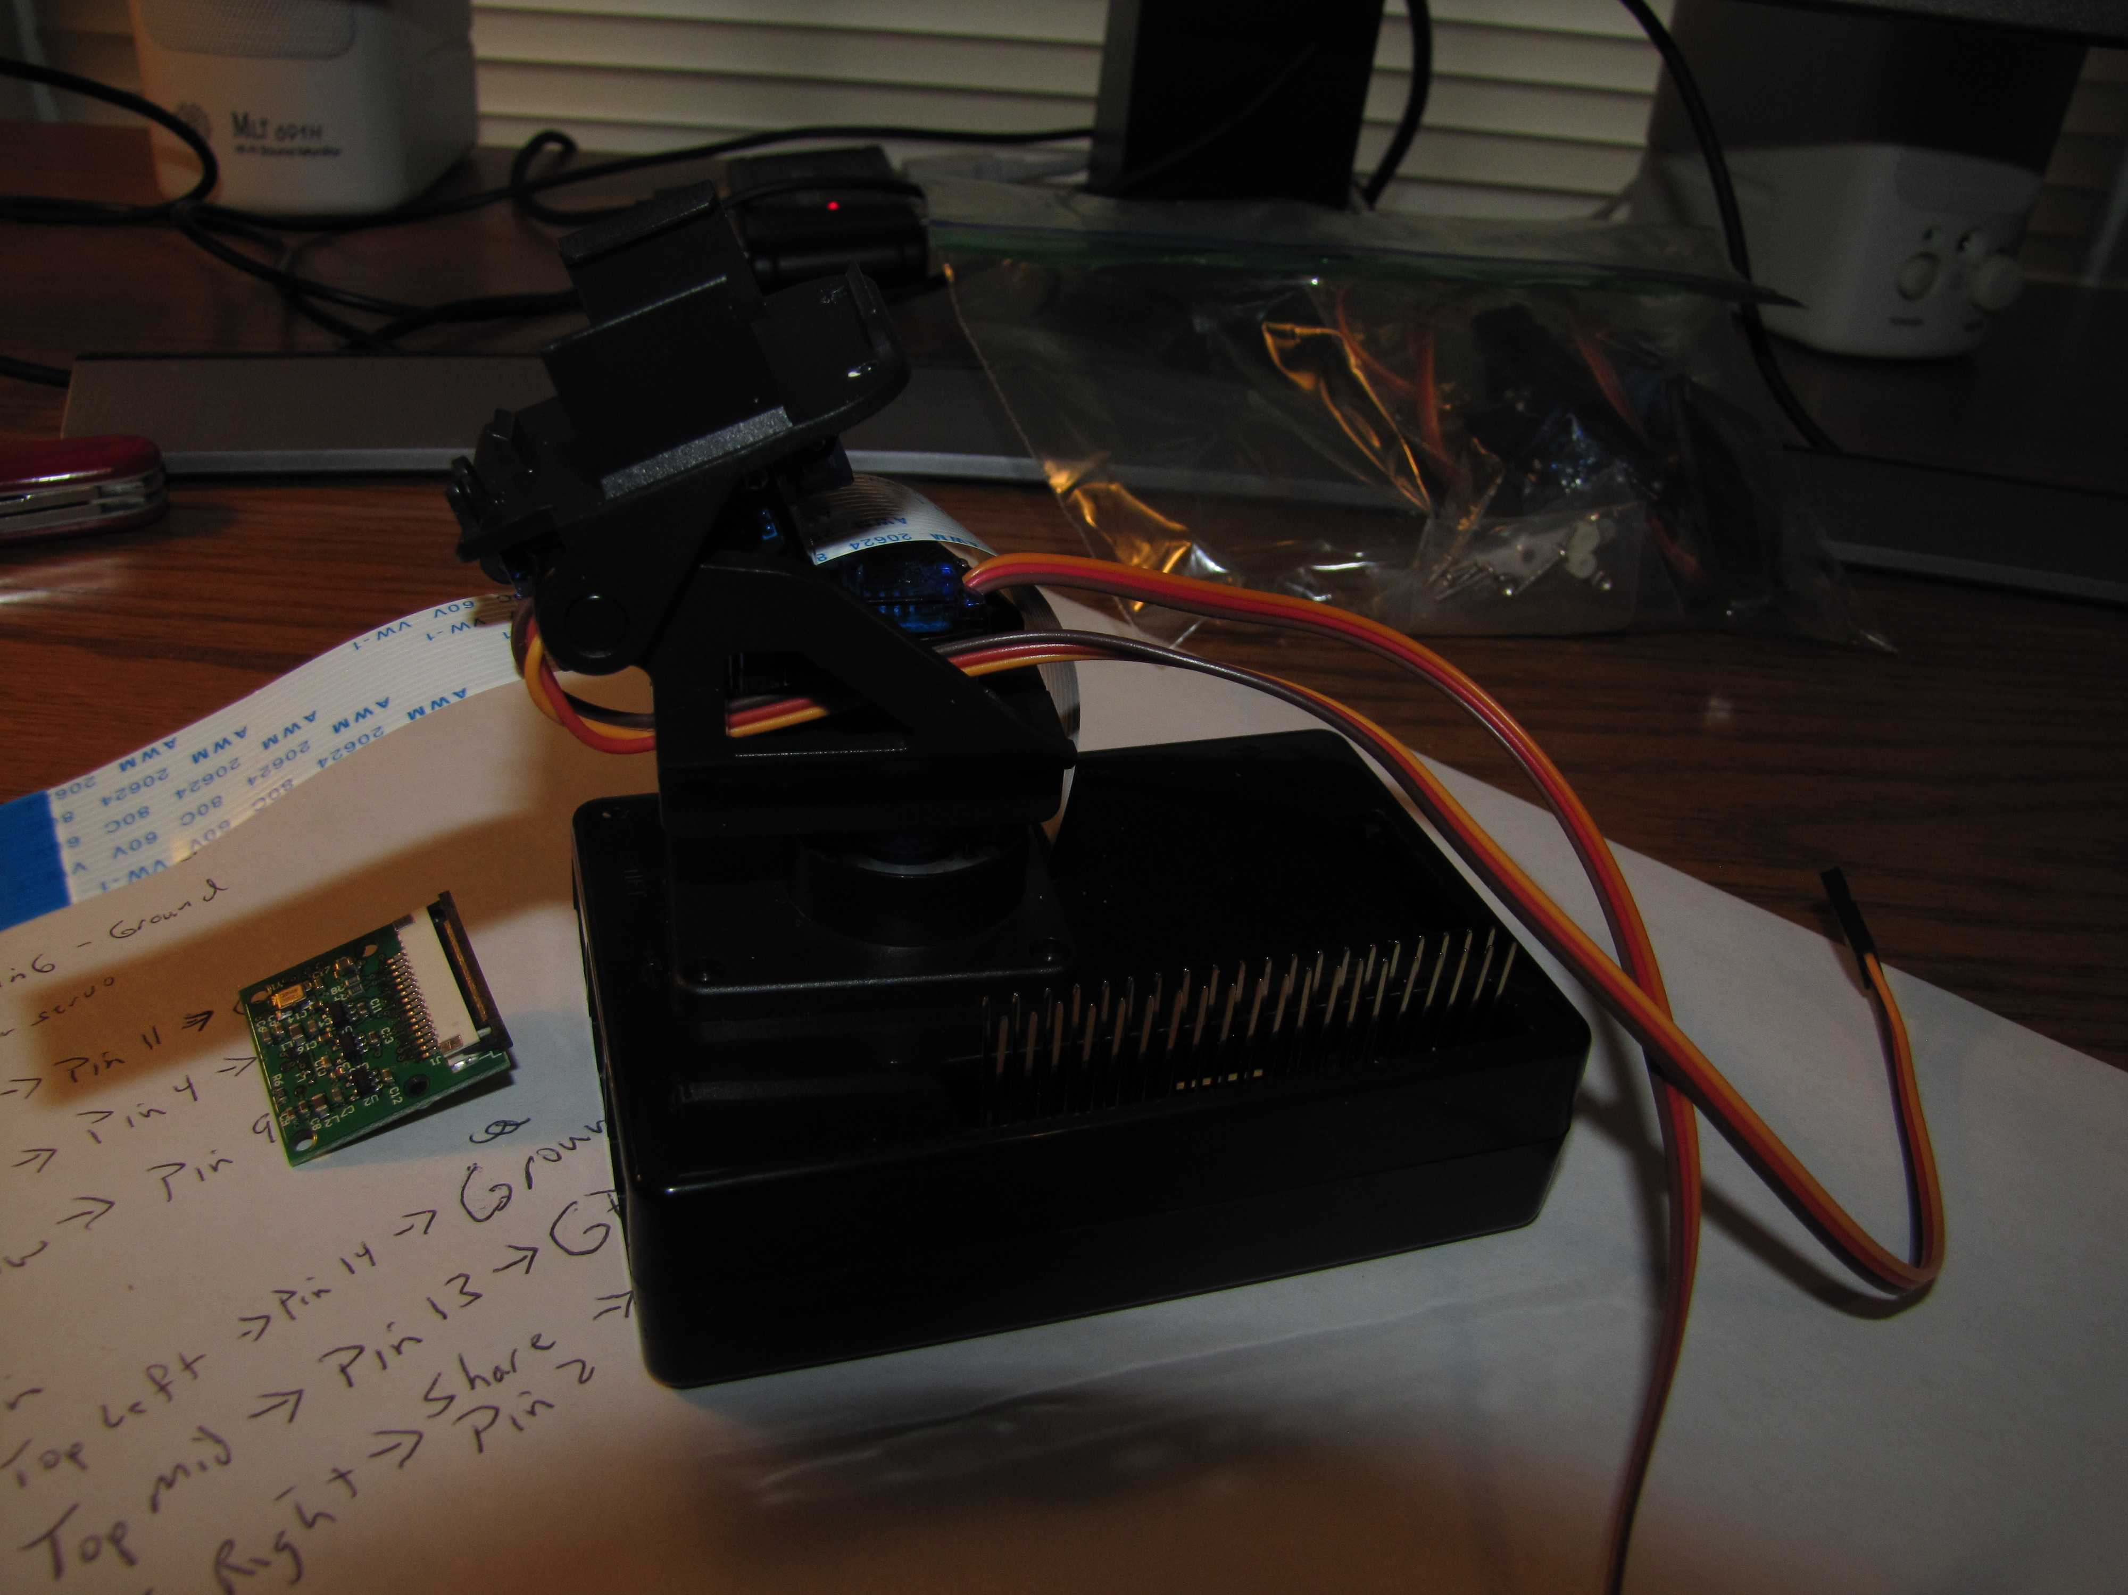
You should feed the servo cables through this slot. Unless you read the instructions and realized you need the camera cable to run through the gimbal, then you need to remove the cable from the camera so you can slide it though the gimbal between the servos. You remove the cable by lifting the socket latch. Once again it doesn’t come out it just lifts up a little. You lift it a little on both sides of the slot and the cable will come out.

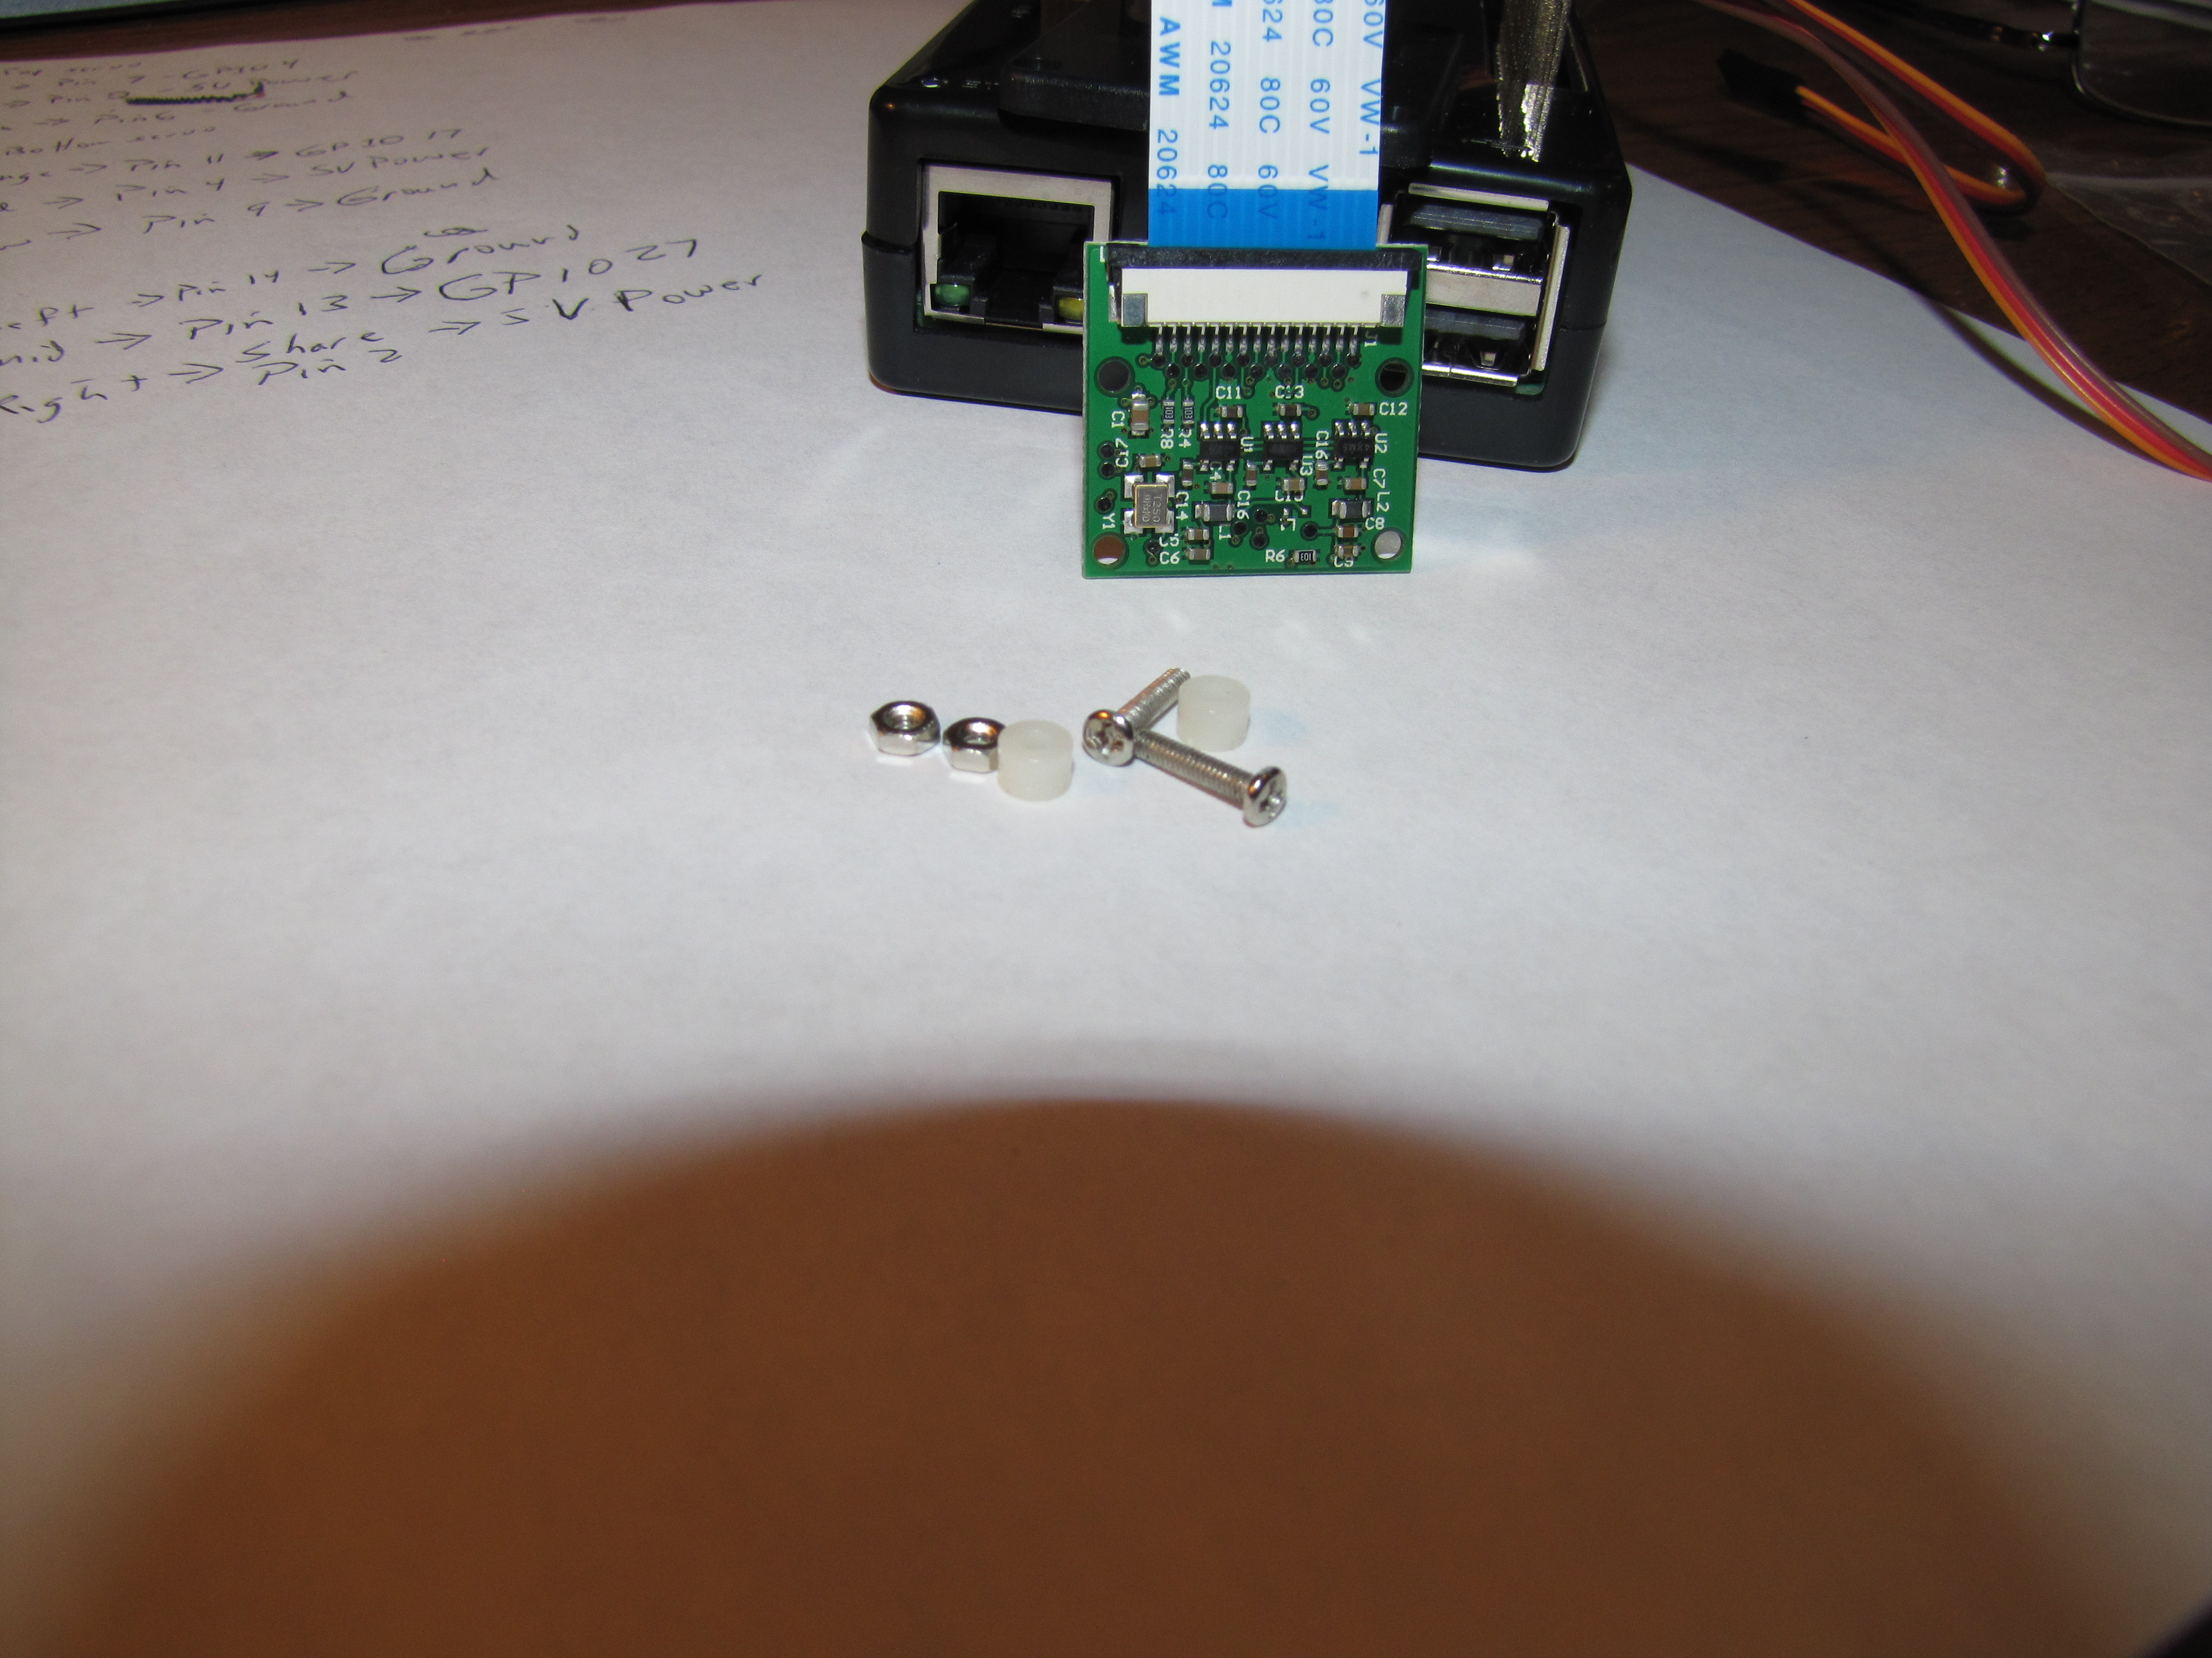
Connect the cable back to the camera, with the blue facing like this.

Here you also see the pieces we need to connect the camera to the top of the gimbal. The holes in the top of the gimbal are small and so screws may be tight enough when screwed into the top so that you don’t need the nuts.

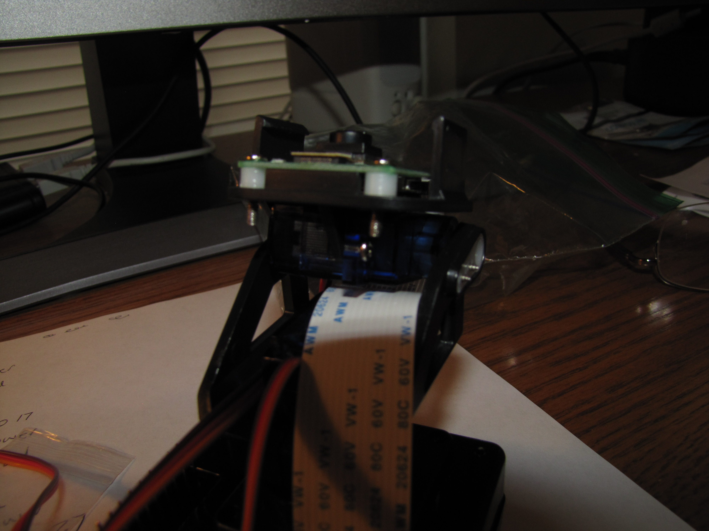
This is the camera screwed onto the top of the gimbal without the need for nuts to hold it in place. The spacers are between the camera and the gimbal.

The final step is to screw the gimbal onto the top of the case, with two screws the mentor has. The case is drilled with two holes that you screw the bottom of the gimbal into.

