The following diagram shows the GIPO pin layout for the raspberry pi. The even number pins are by the edge of the board, with pin 1 and 2 being closes to the corner of the board.

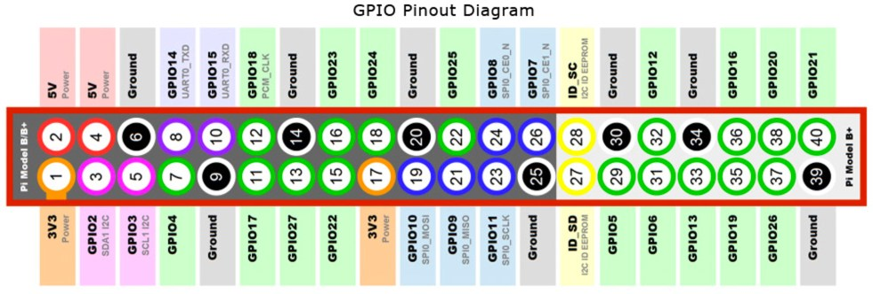
Your raspberry pi should be disconnected from power (micro USB should be disconnected!!) to make the new pin connections.

- We start by disconnect all wires currently connected to the Raspberry pi GPIO pins.

The next step is to connect the AdaFruit servo control board. This board is designed to sit on top of the 40 GPIO connectors, however if we put it on top we can’t access all the pins we need to access. As such we’ll utilize 4 wires to connect the boards.
- We need to connect pins 1, 3, 5 and 39 between the two boards. Next we need to connect the servos directly to the 3 pin sets on the top of the adafruit board.

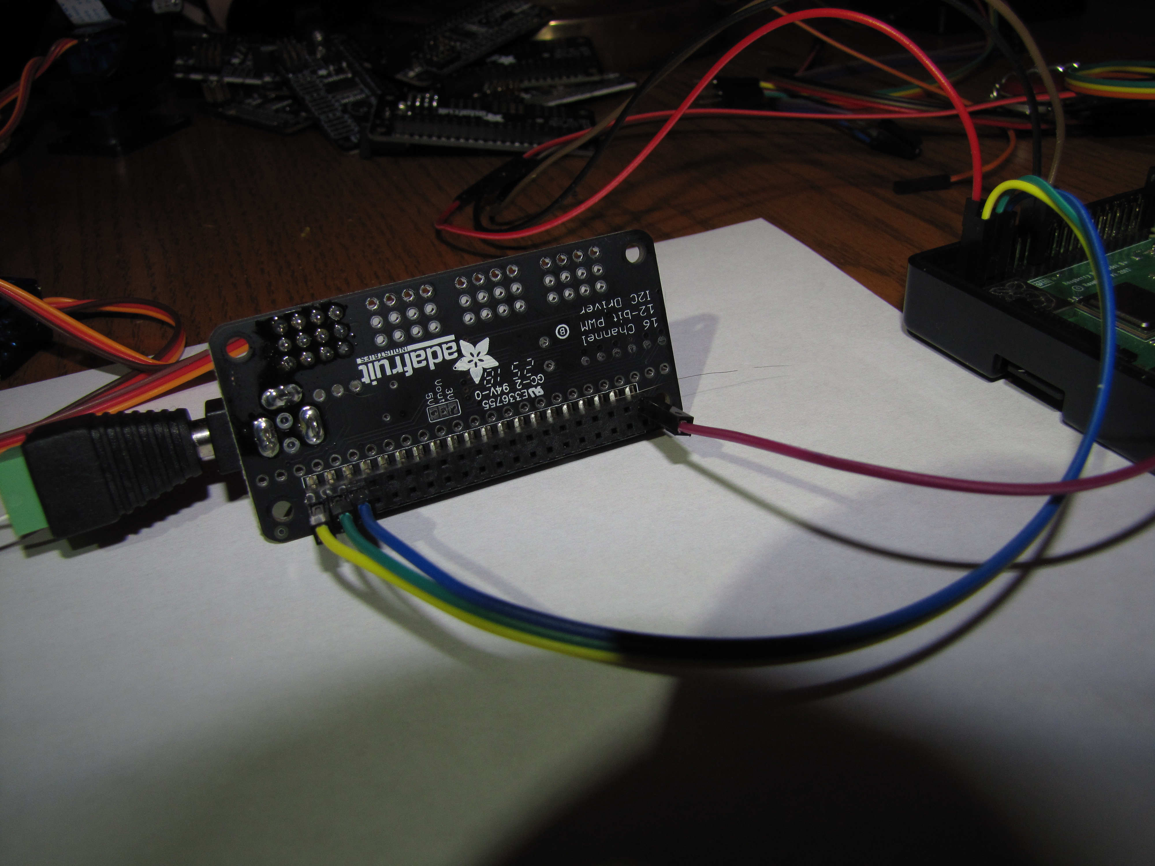

First 3 and last pin on top row

Power connector

Notice I have it sitting on it’s edge so it doesn’t short out.

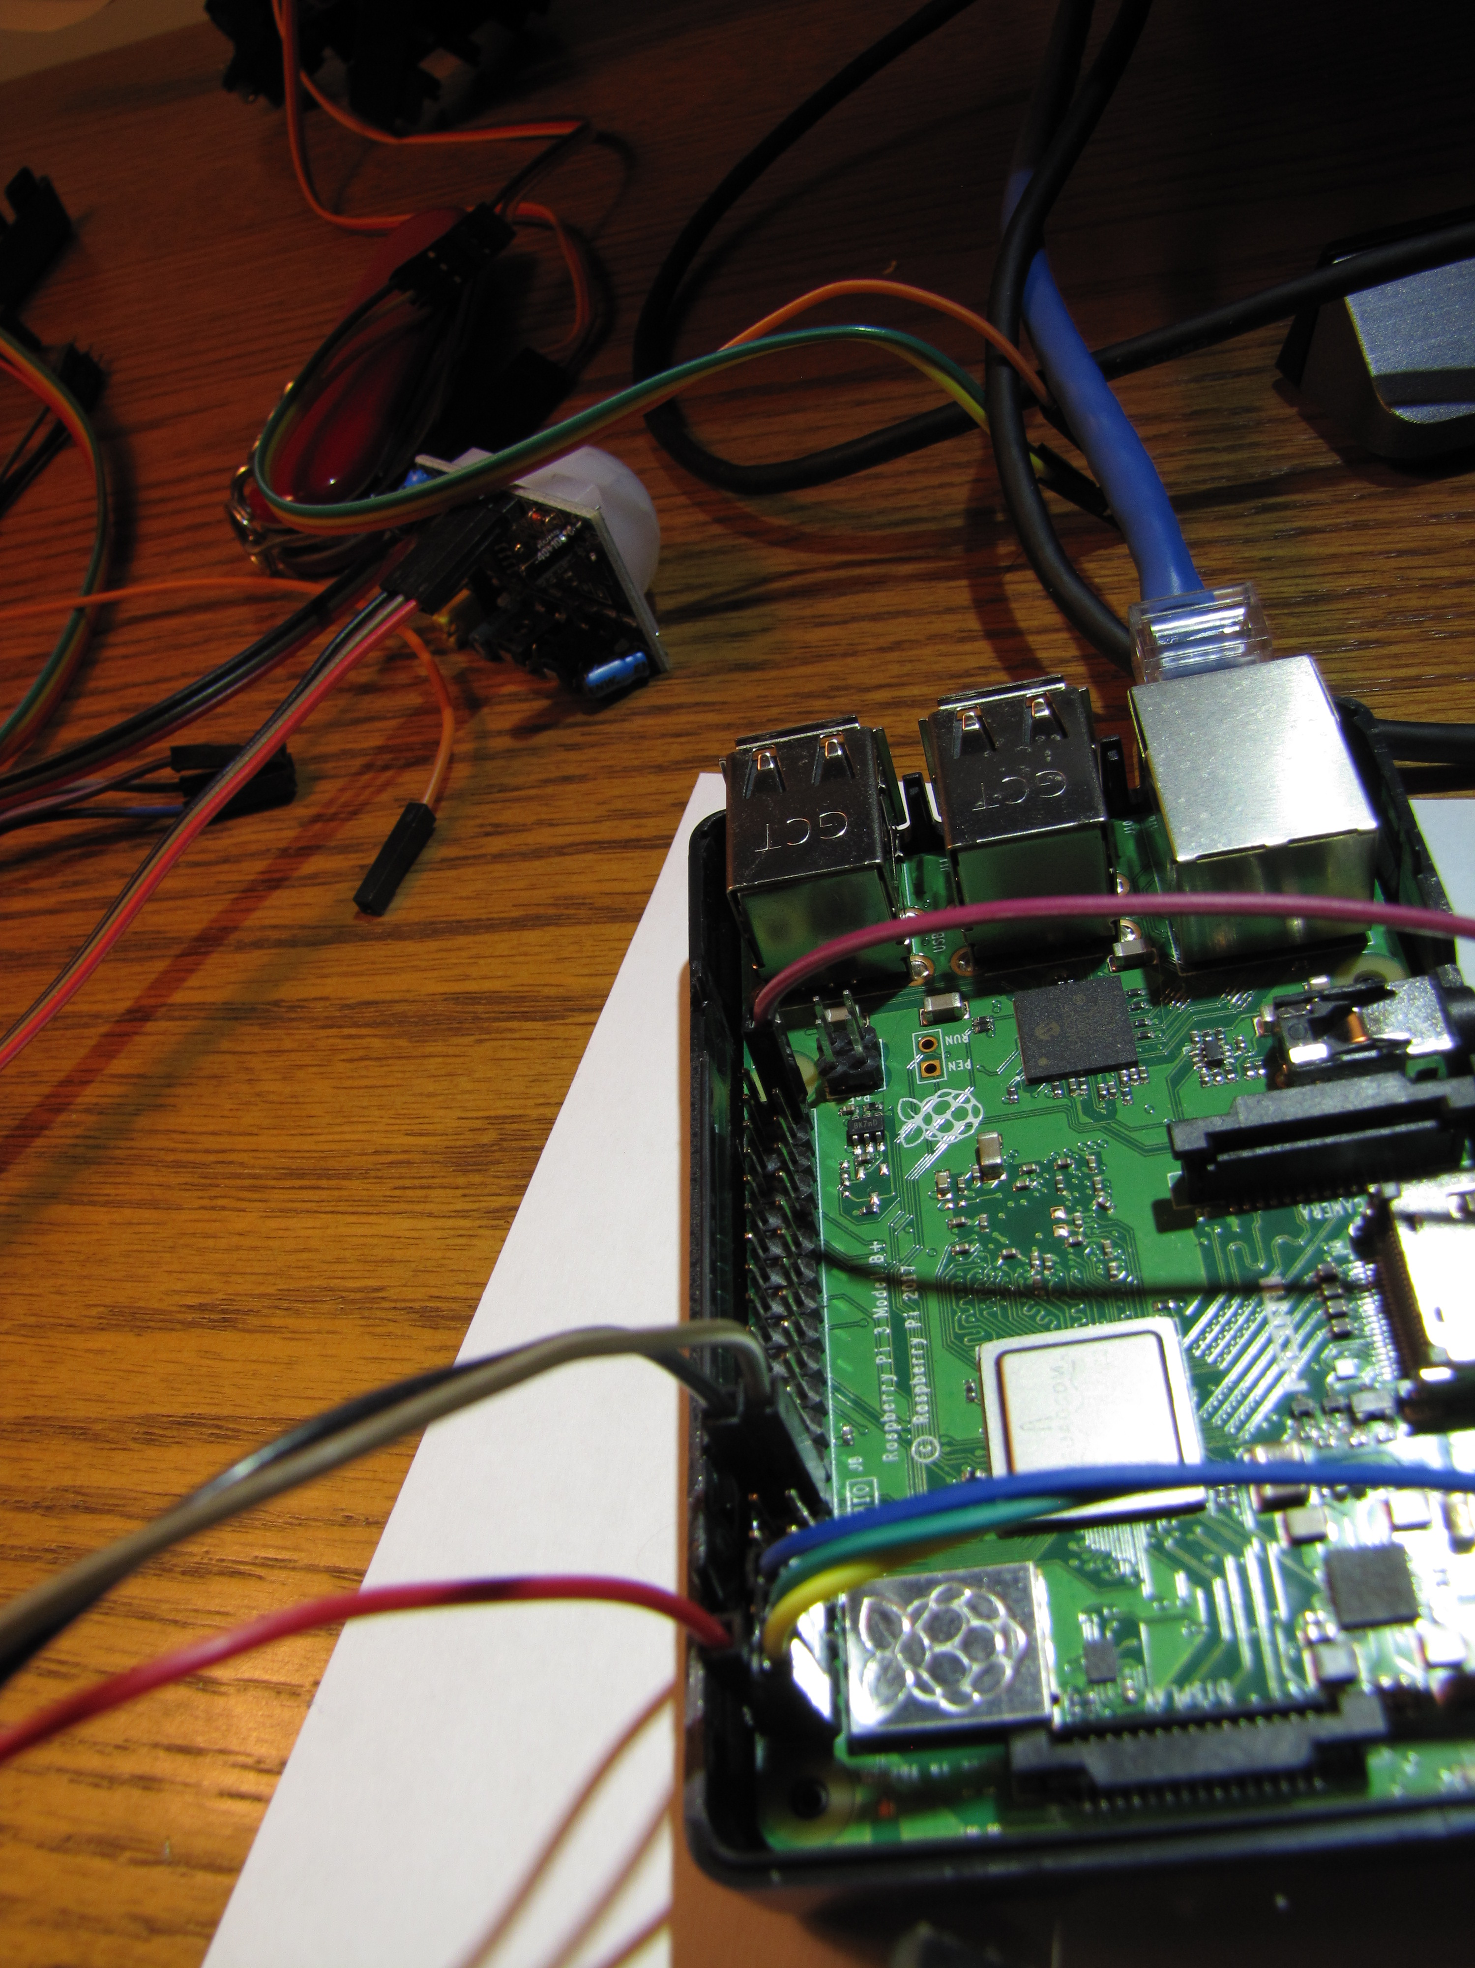

Wires from above connected to first 3 pins and last pin on row away from edge

The adafruit board has 4 sets of 3 pins exposed, numbers 0, 1, 2 and 3. The servo brown wire goes to the G pin while the orange wire goes to the S pin.
- The bottom servo should be connected to pin set 3.
- The top servo should be connected to pin set 2

Connect the laser to the pi
- Blue wire to the ground pin 9
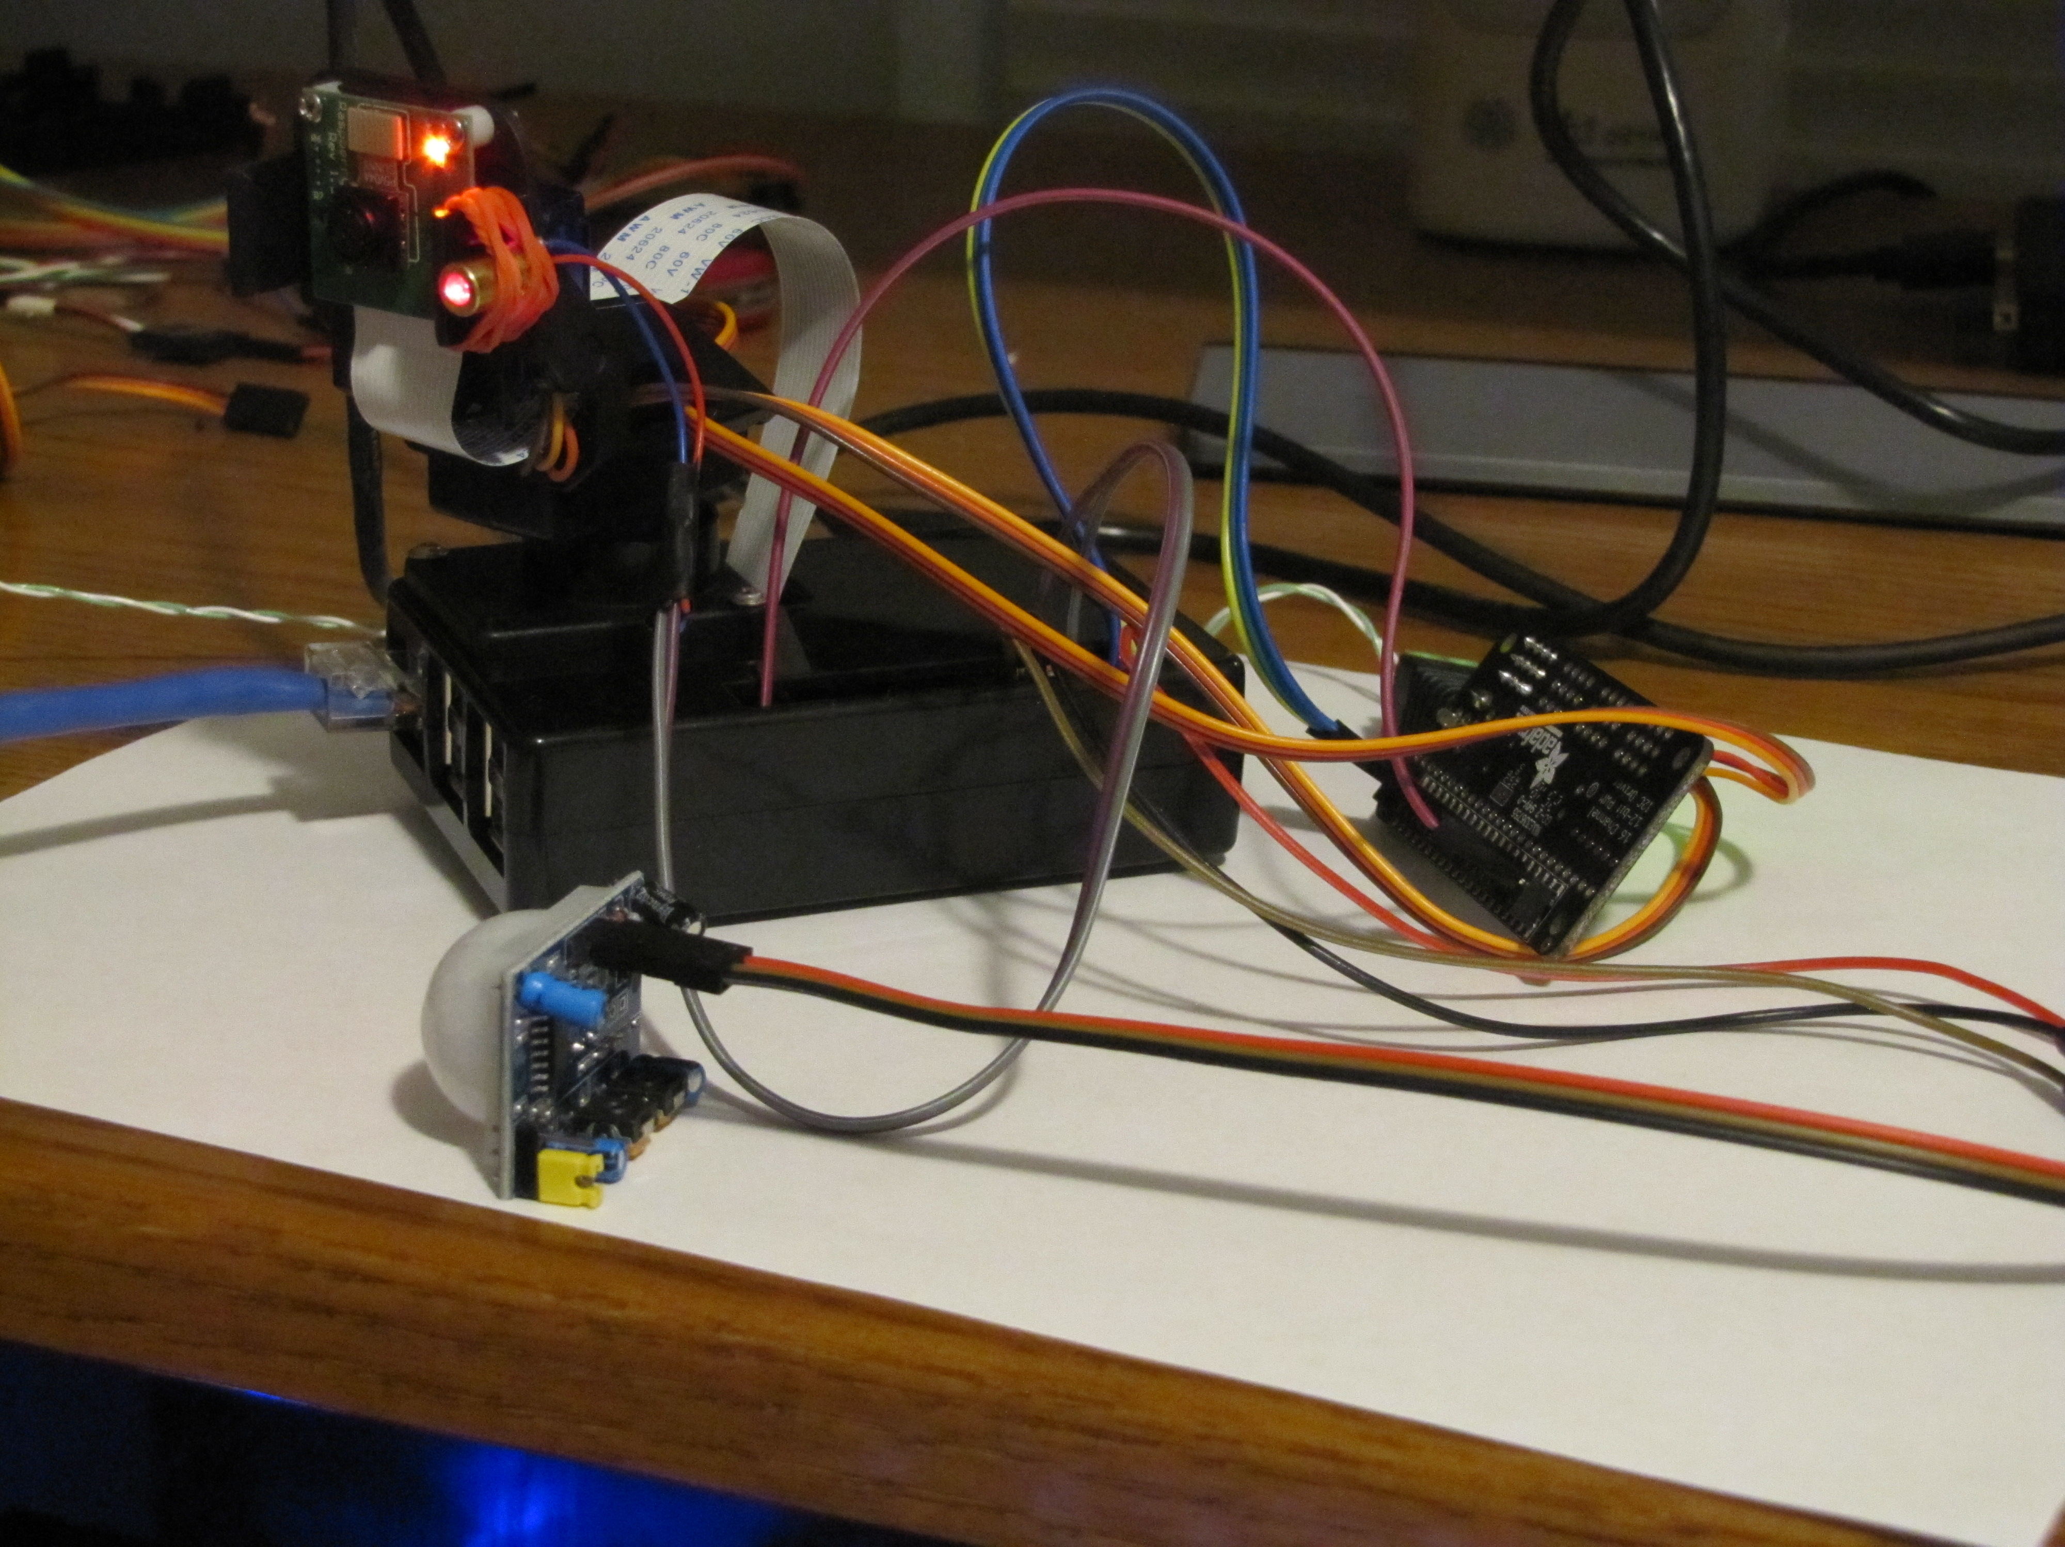
- Red wire to pin 13 (GPIO 27)
- Use a rubber band to connect the laser to the gimbal

Rubber band holding laser in place

Motion detector sitting on it’s edge

Note: Once you’ve made these connections have the mentor check your work!!!

Looking at the back of the motion sensor with the 3 pin set to the top.
- Connect the motion sensor left most pin to the PI pin 14 (ground)
- Connect the motion sensor center pin to PI pin 16 (GPIO 23)
- Connect the motion sensor right pin to the PI pin 2 (5V Power)

Provide power to ada fruit board
- Connect the 5V power connector, which can be seen in the first picture to the adafruit board

Provide power to your pi
- Make sure you have your network cable between the pi and your laptop
- Plug in the USB power cable
- The red and green lights on the Pi board on the edge opposite the USB ports should light. After a minute or so the green light will go off and mostly stay off, at which point you can advance

We need to find the IP address assigned to the pi
- Bring up a command window on the laptop and enter command: arp -a
  - You’re looking for the section that has Interface 192.168.137.1 – It’ll look something like this:
Interface: 192.168.137.1 --- 0x1c
Internet Address Physical Address Type
192.168.137.140 b8-27-eb-3e-36-7c static
192.168.137.255 ff-ff-ff-ff-ff-ff static
224.0.0.2 01-00-5e-00-00-02 static
224.0.0.22 01-00-5e-00-00-16 static
224.0.0.251 01-00-5e-00-00-fb static
224.0.0.252 01-00-5e-00-00-fc static
239.255.255.250 01-00-5e-7f-ff-fa static
255.255.255.255 ff-ff-ff-ff-ff-ff static
  - Hopefully you’ll have a 192.168.137. XXX address that doesn’t end with 255, this should be the IP address for your pi, so remember this address
- Use putty and make an ssh connection to your pi’s IP address:
  - user name is pi and password is raspberry

We need to install software on the pi the allows us to access the second board. From the pi command prompt:
- sudo apt-get update
- sudo apt-get install python-smbus i2c-tools
- sudo pip install adafruit-pca9685
- sudo pip3 install adafruit-pca9685
- sudo pip3 install adafruit-circuitpython-servokit

Make i2c is enable on the Pi
- sudo raspi-config
- Select “Interfacing Options”
- Select “I2C”
- Select “Yes” to question “Would you like the ARM I2C interface enabled
- Select “OK” once it tells you the interface is enabled
- Select “Finish” to exit the tool
- Note: if it ask you if you want to reboot, respond yes

Check that the Pi sees the Adafruit board
- sudo i2cdetect -y 1
- The response should show 40 and 70 in the 0 column

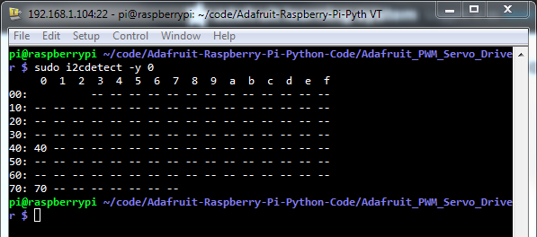

If you see the above with 40 and 70 you can continue

We need to grab some updated software to control the servos, laser and motion detector
- On the laptop web surf to: http://connectionblocks.com/pi/panandtilt/ and grab the file add_laser_motion.tgz.
- Use WinSCP to move the file over to the pi.

Back on the Pi command prompt we need to extract the updated software
- Check what directory your in: pwd
- It should be the home directory for user pi
- See if the file is there: ls -l
- Assuming you see add_laser_motion.tgz expand it: tar -xzvf add_laser_motion.tgz

One of the extracted files is an updated version of the network based servo controller software
- Verify the files have been uncompressed via: ls -l
- You’re looking for networkControl.py

Assuming you see the controller you can move on
- Start it via: ./networkControl.py &
- When it starts you’ll get some debug information and the servo will probably move some.

Go to your web browser and see if the up/down/left/right buttons move the survo

Now add a button that will allow you to enable or disable the laser. NOTE !!! do not have the laser pointer towards someone’s face when you turn it on !!!!!
- From pi command line copy the button update:
sudo cp userbuttonsL /var/www/html/userbuttons
sudo cp laser.sh /var/www/html/macros/

- Refresh your browser to see if you have the laser button, if you do, use it to try and turn the laser on and off

The motion sensor is the last item. It’ll probably be hard to test with everyone sitting around together. To check how often it’ll kick off start some software to read the data from the sensor
- Start the motion sensor detection software: ./motion-tst.py

Assuming it’s pointing in some direction that doesn’t have motion it shouldn't print anything out. Once it sees motion you’ll get two types of messages:
There was a movement!
Sensor timeout to low again
The first indicates motion was dectectand the voltage when high. The motion detector holds the voltage high for a little while, the second message prints once the voltage goes low.

If this isn’t kicking off rapidly you can kill this and start a version that will cause a picture to be captured when motion is detected.
- Kill the current motion detection application via: <ctrl>c
- Start the picture capture version: ./motion-capture.py
When it sees motion if you’re watching the web browser you will see the “record image” button go “Yellow” . The Download Videos and Images button will allow you to look at the pictures.

