The following came from https://pimylifeup.com/raspberry-pi-vpn-server/ , I’ve copied them just to updated them for out setup.

1. Setting up a Raspberry Pi VPN Server can be quite a complicated process, normally you would have to install the software, generate the encryption keys, add the port to the firewall, set the Pi to keep a static IP address and much more.
Luckily for us, there is a much easier way to set up a Raspberry Pi VPN server thanks to an install script called PiVPN, this handles all the grunt work for setting up a VPN and reduces the potential for making mistakes.
(NOTE I already did this) Before we get started, we should first change the password of the default pi user, this is to ensure if someone managed to gain access to your VPN they wouldn’t be able to access your Raspberry Pi easily.
passwd
2. With the password changed we can begin the process of setting up our VPN server on the Raspberry Pi. We can begin this process by running the command below, this command downloads the install script from PiVPN’s GitHub page and runs it.
Normally running a script straight from a URL is a poor idea, as it can be an easy way for someone to gain access to your Raspberry Pi and do some serious damage.
However this is a trusted source that we have verified, if you want to check out the code yourself, just go to the location of the script.
curl -L https://install.pivpn.io | bash
3. Once you have run the above command, you should be met with the following screen. To proceed to the next screen, you just need to press enter.
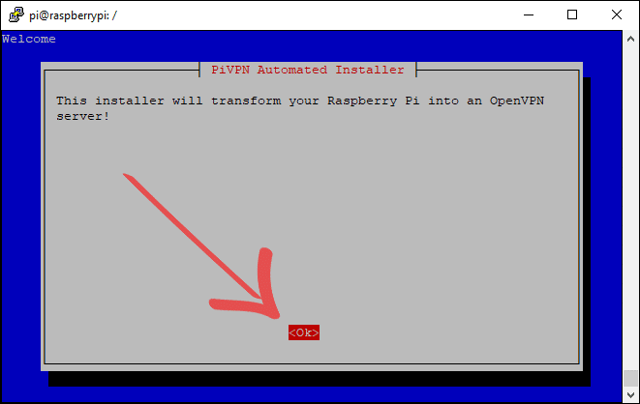
4. The next screen explains that it will need to set up a static IP address for the Raspberry Pi, this is so that when the Raspberry Pi is restarted for any reason, it will try and utilize the same IP address again.
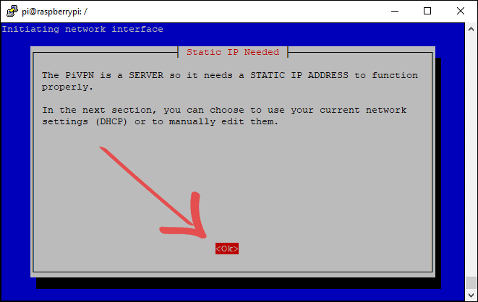
5. On here we will just be selecting <Yes> to using the current network settings as a static local IP Address. If you are unhappy with the current settings, then select <No>.
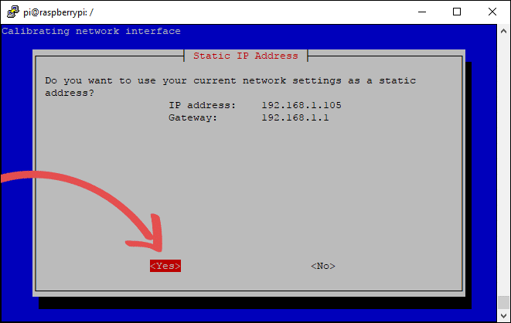
6. The warning you are presented with next basically warns you that there is a chance your router will assign the IP address to another device. Luckily most routers also let you set the IP address to static within its interface as well. For the most part, you should be able to ignore it. So just select <Ok> and press enter.
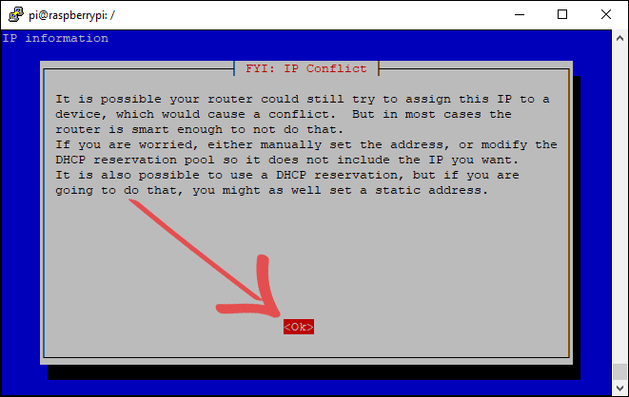
7. The next screen explains that we will need to set a local user that the OVPN configurations will be created for. You can just select <Ok> and go onto the next screen.
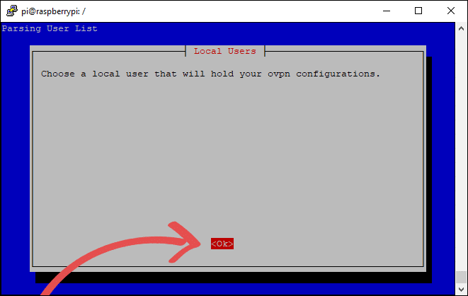
8. Here we will be presented with a list of users that we can choose. In this tutorial, we will be just making use of the default pi user. Once you are happy with the user you have selected, press enter.
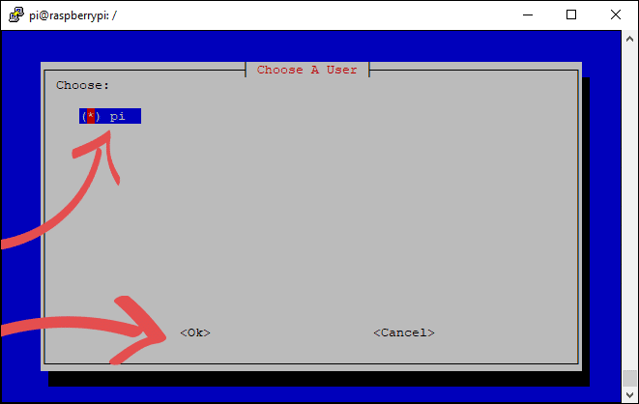
9. Now you will be presented with an explanation of unattended upgrades; this feature makes Raspbian automatically download security package updates to your Raspberry Pi daily.
This setting helps secure your Raspberry Pi which is incredibly important since we will be opening a port on the router. Select <Ok> to continue.
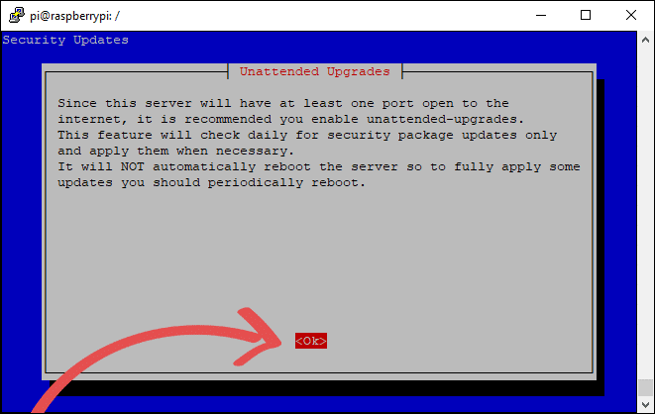
10. On this screen, we highly recommend selecting <Yes>. Leaving this feature switched off can pose a significant security risk to your Raspberry Pi and potentially your home network.
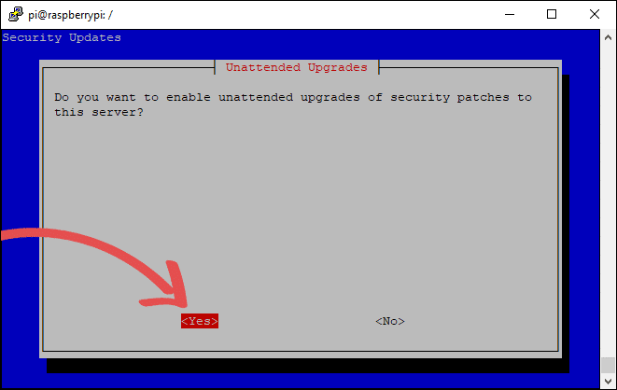
11. Now we will be asked to set the protocol that OpenVPN will run through, we will be making use of UDP, only select TCP if you know why you need it. Press enter when you are happy with your choice.
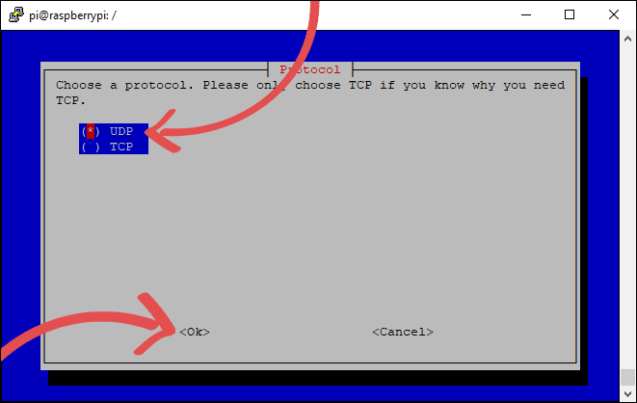
12. Now we will be selecting the port OpenVPN will operate through, while you can press enter to retain the default port of 1194, and we do recommend changing this.
The reason to change it is that if someone does a default port scan on your IP address, it will be much harder for them to know you have a VPN up and running.
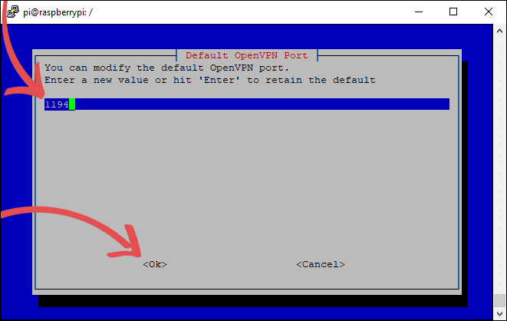
13. Below is the confirmation screen for the port number you set, if you are happy with the port, you have chosen then select <Yes> to continue.
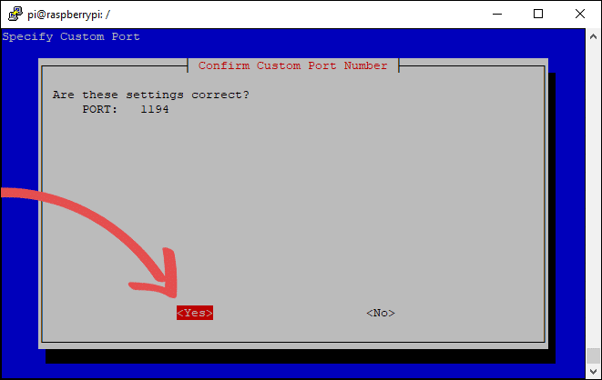
16. You will now be asked if you want to utilize the 2.4 version of the OpenVPN software. As we
we’re installing the lastest open vpn select <Yes>
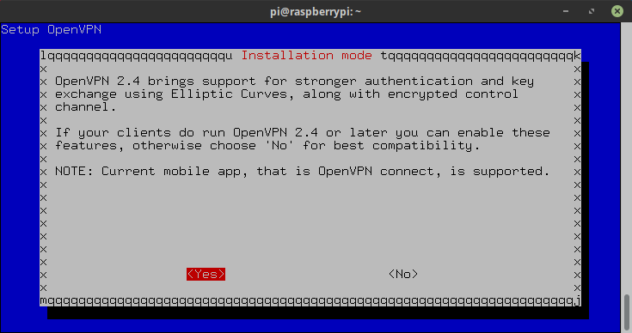

14. Now we must choose the encryption key size, and we recommend using 2048-bit encryption as it currently offers good protection without sacrificing speed.
If you are truly worried about the encryption of your connection, then you can make use of the 4096-bit encryption key. However, this will take some serious time and will slow the overall connection.
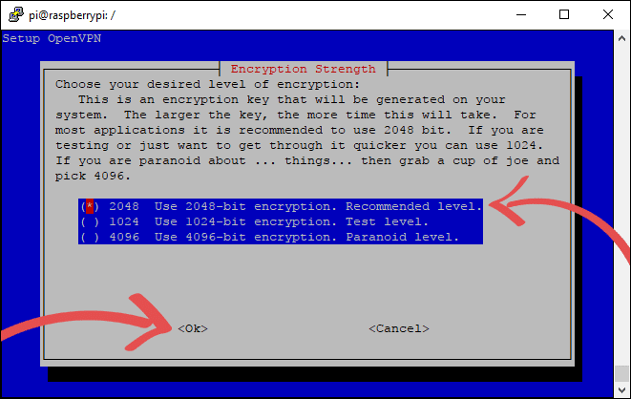
15. The next screen basically tells us what the PiVPN script is about to do, expect this process to take some time, it can take anywhere from a couple of minutes to an hour. Select <Ok> to proceed.
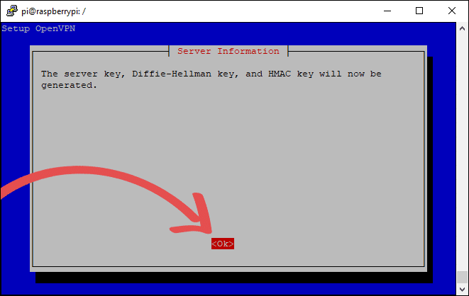

17. We now need to decide whether we want to make use of our public IP Address or utilize a Dynamic IP service such as FREEDNS from afraid.org.
As we have a dynamic IP address, then use the arrow keys to navigate up and down, and use spacebar to select the DNS Entry before pressing Enter.
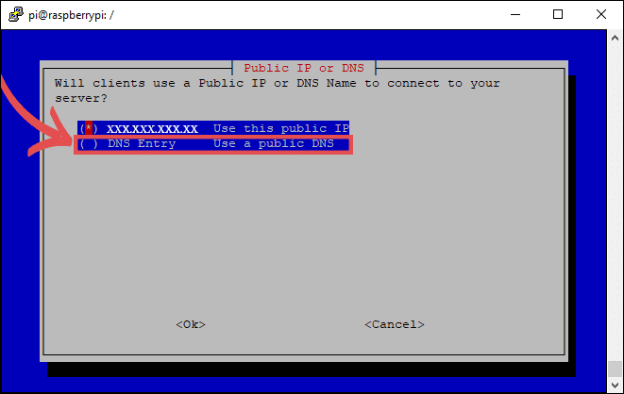
18. If you selected DNS, then you can set your DNS name here, this can be either an xxxxx.no-ip.org address or a domain name of your own choosing that points to your IP address. You should’ve set this up before completing this tutorial. Note this is the domain you set up earlier.
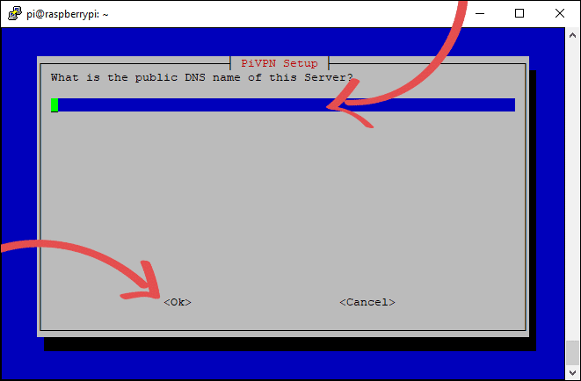
It’ll ask you to verify the domain name, so select <Yes> if it’s right and <No> if you need to update the domain
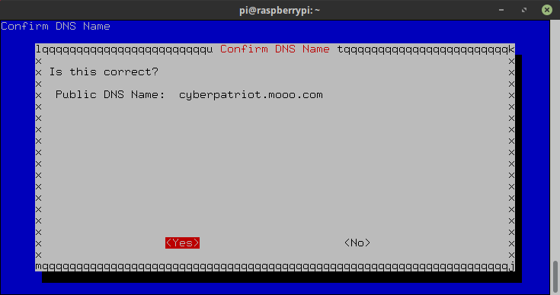

19. The next step is to select a DNS provider. A DNS provider is what resolves a URL into an IP address.
For the sake of simplicity, we will be just making use of Google’s public DNS servers. However, they are known for recording the data that passes through them.
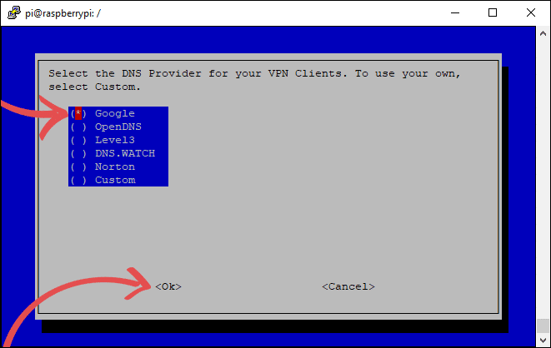
20. You have now successfully completed the installation of your Raspberry Pi VPN, while there are still a couple more things you will need to complete to allow connections, you are now about 90% done.
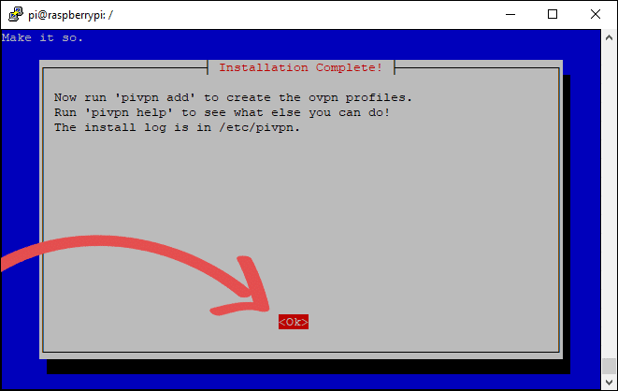
21. We will now be greeted by a screen asking for us to reboot the Raspberry Pi, just select <Yes> to the next two screens as it’s crucial you reboot.
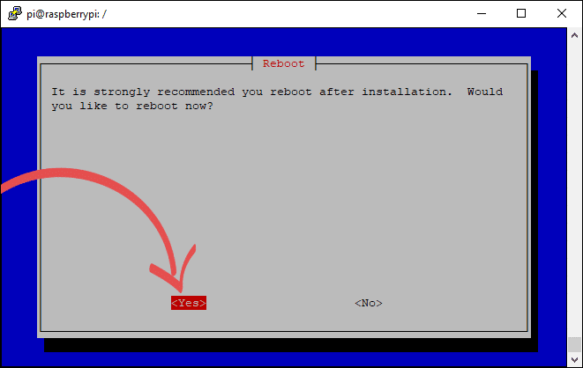

Setting up your first OpenVPN User
1. Normally setting up a user for OpenVPN would be a painful process as you would have to generate the individual certificates for the user, luckily we can do this in one single command thanks to PiVPN.
To begin adding the user, run the following command:
sudo pivpn add
On this screen, you will need to enter a name for the client, and this name will act as an identifier so you can differentiate between different clients.
It will also ask you to set a password for the client, and it is important to make this something secure and not easy to guess as this will secure the encryption key.
So, if someone can guess the password easily, it severely reduces the security of your VPN.
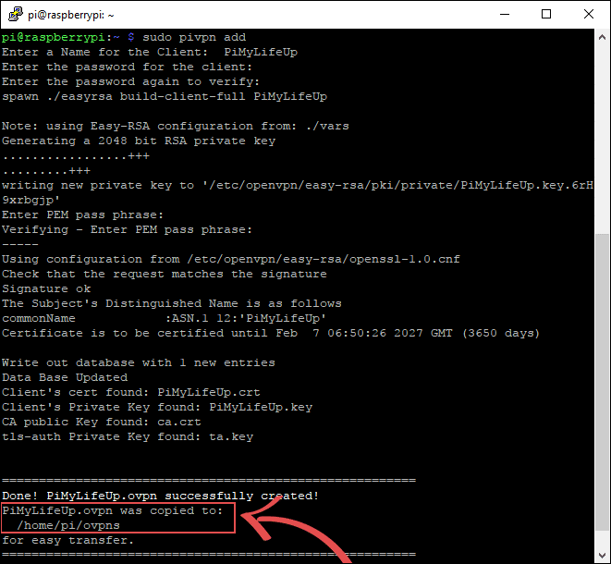
Once you press enter to these, the PiVPN script will tell Easy-RSA to generate the 2048-bit RSA private key for the client, and then store the file into /home/pi/ovpns.
/home/pi/ovpns is the folder we will have to gain access to in the next few steps so we can copy the generated file to our devices.
Make sure you keep these files safe as they are your only way of accessing your VPN.
2. Now that our new client has been set up for OpenVPN with our passphrase we will now need to get it to the device that we intend on connecting from. The easiest way to do this is to make use of SFTP from within your home network. We use winscp, create a new site with a “Host name” of your dynamic DNS address and the ssh port for your PI.

3. Once you have successfully logged in, we need to look for the ovpns folder, as this is where the file we need will be located. Once you have found the folder, drag and drop the openVPN .ovpn file you just created over to your laptop. I suggest you drop it into the download’s directory. This file needs to be updated prior to being imported. You want optn the .ovpn file and on the about the 4th line it’ll look something like this:
remote cyberpatriot.mooo.com 1194
You need to change the 1194 number to the port number provided to you (4500X) for the VPN connection and then save the file.

3.5 You will need this file when you install the openvpn client which you can pulle from:
http://connectionblocks.com/tools/openvpn-install-2.4.6-I602.exe
4. Install this client, on its first run it will automatically minimize to the taskbar( NOTE it did not run automatically for me, so I had to run it and then import the file), right click on the icon, then select “Import file…”
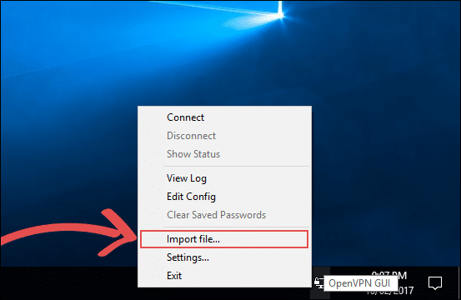
5. You will be presented with a file explorer screen, in here go to where you saved the .opvn file from earlier. Once you have found it, double-click the file to import into the OpenVPN client.
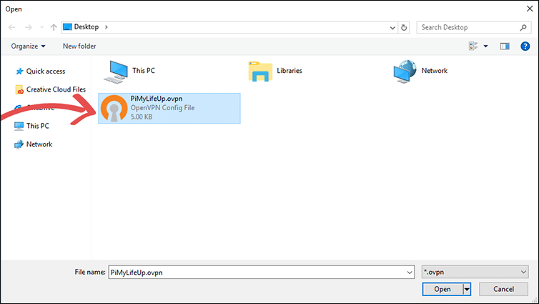
6. You should now be presented with a dialog telling you the file has been successfully imported into OpenVPN. Just press the OK button to proceed. I also got a pop up asking if I wanted to add myself to the OpenVPN group. Answer “Yes” to this dialog box.

8. Now right click the OpenVPN client icon in the taskbar again, this time click Connect.
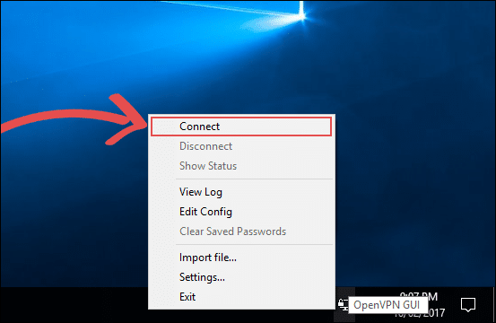
9. Now the OpenVPN client will attempt to read the data located in the .opvn file. Since we have a passphrase set, it will now ask for you to enter the passphrase you set earlier on in this tutorial.
Once you are certain you have entered the correct passphrase, press the OK Button.
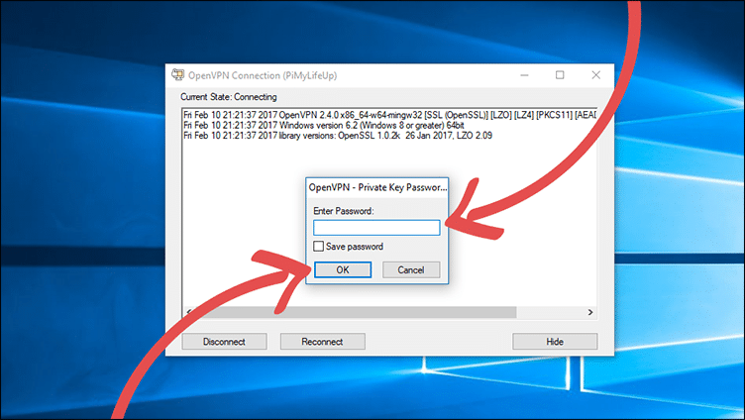
10. The OpenVPN client will now attempt to connect to your Raspberry Pi’s VPN server. If the OpenVPN icon turns to a solid green, then it means that you have successfully connected into your VPN.
However, if it turns yellow and fails to turn green after 60 seconds that means something is causing the connection to fail.
In most cases the connection failure is caused by port forwarding issues, my router, for instance, has numerous issues with port forwarding. It is easiest to google your router’s model number to try and find help on any issues you may face with port forwarding. Some ISP’s (Internet Service Provider) also block specific ports, so it’s best to check that your ISP is not blocking the port you plan on using.
If you are using a dynamic DNS service, then make sure that the service is being correctly updated with your latest IP address if the IP address has changed, but the DNS setting hasn’t then it will cause the connection to fail.
Hopefully, by now, you will have a fully functional VPN that you’re able to connect to successfully.

Uninstalling the VPN from your Pi
1. If for some reason you want to remove your VPN from your Raspberry Pi you can simply utilize the following command on it.
This command will utilize the pivpn software to uninstall the VPN tunnel.
sudo pivpn uninstall
I hope that this tutorial has shown you how to set up a Raspberry Pi VPN Server and that you haven’t run into any issues. It’s certainly a great project for anyone who wishes to set up a cheap always-on VPN network. If you have some feedback, tips or have come across any issues that you would like to share, then please don’t hesitate to leave a comment below.

