The following diagram shows the GIPO pin layout for the raspberry pi. The even number pins are by the edge of the board, with pin 1 and 2 being closes to the corner.

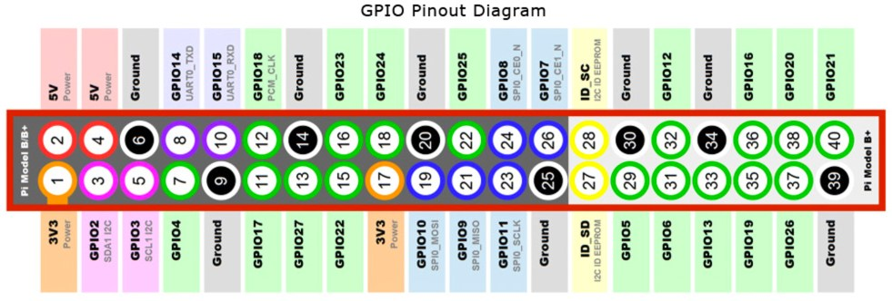
Your raspberry pi should be disconnected from power to make the pin connections.
You have 4 touch pads and a breadboard. The beadboard provides a simple way to connect multiple pins together. You will see the pins are in groups of 5. Each group of 5 pins connect
- We need to run pin 1 (3v3) and pin 9 (ground) from the pie to the breadboard. Then you need to connect the power (vcc) and ground pins from the breadboard to each of your 4 touch sensors
- Pins 11, 13, 15 and 19 and then connected from the pi to the SIG pin on the touch sensor.

Advance to 02-Raspbian-load-software.doc

